Agenda Requirements

Prepared For
SCINET

November, 2006
v1.0

Prepared By
Karla Alvarado
UCF SCINET Project Manager

Contributors
Dr. Ronald Eaglin
UCF SCINET Program Manager

Olga Semukhina
UCF SCINET Business Analyst

Tammi Rhode
Seminole County SCINET Business Analyst

Irene Troutt

SCINET Core Group

Table of content
Abbreviations 5
Introduction 5
Problem Statement 5
Objectives 7
Stakeholders 7
Description 9
Processes/Modules 10
Calendar Administration: (Completed. Requirement documentation to be done in future) 10
Add sessions (Completed. Requirement documentation to be done in future) 10
BCC standard session (Completed. Requirement documentation to be done in future) 10
Working session (Completed. Requirement documentation to be done in future) 10
Special public hearing session (Completed. Requirement documentation to be done in future) 10
Special session: (Completed. Requirement documentation to be done in future) 10
Legislative update (Completed. Requirement documentation to be done in future) 10
Delete sessions (Completed. Requirement documentation to be done in future) 10
Update sessions (Completed. Requirement documentation to be done in future) 10
Project Process Setup: (Completed. Requirement documentation to be done in future) 11
Create Project/Process (Completed. Requirement documentation to be done in future) 11
Attach documents (Completed. Requirement documentation to be done in future) 11
Update Project/Process (Completed. Requirement documentation to be done in future) 11
Delete Project/Process (Completed. Requirement documentation to be done in future) 11
Project Setup: (Completed. Requirement documentation to be done in future) 11
Create Project (Completed. Requirement documentation to be done in future) 11
Update Project (Completed. Requirement documentation to be done in future) 11
Delete Project (Completed. Requirement documentation to be done in future) 11
Associate process to project (Completed. Requirement documentation to be done in future) 11
Search projects: (Completed. Requirement documentation to be done in future) 11
Create Agenda item (Completed. Requirement documentation to be done in future) 11
Agenda Item: 11
Create item: (Priority 1) 11
Agenda items type: 11
Consent (Completed. Requirement documentation to be done in future) 11
Regular (Completed. Requirement documentation to be done in future) 11
Public Hearing: (Completed. Requirement documentation to be done in future) 11
Briefing (Completed. Requirement documentation to be done in future) 11
Continued (Priority 1) 11
Agenda Memorandum Enhancements (Priority 1) 13
Save item (Completed. Requirement documentation to be done in future) 14
Request schedule (Completed. Requirement documentation to be done in future) 14
Associate item to a project process (Completed. Requirement documentation to be done in future) 14
Non-project agenda items (Completed. Requirement documentation to be done in future) 14
Attach documents: (Completed. Requirement documentation to be done in future) 14
Attach documents Enhancements: (Priority 1) 14
Attach documents Enhancements: (FOR THE NEXT AGENDA VERSION-CR) 14
300-feet notice (FOR THE NEXT AGENDA VERSION-CR) 14
Description: 14
Business Requirements: 15
Proof of publication (FOR THE NEXT AGENDA VERSION-CR) 17
Description 17
Business Requirements 18
Placard (FOR THE NEXT AGENDA VERSION-CR) 21
Description 21
Business Requirements 21
Associate item to a project process (Completed. Requirement documentation to be done in future) 24
Non-project agenda items (Completed. Requirement documentation to be done in future) 24
Update item (Completed. Requirement documentation to be done in future) 24
Inbox: (Priority 1) 24
Request schedule (Completed. Requirement documentation to be done in future) 24
Request reschedule (Completed. Requirement documentation to be done in future) 24
Send for review (Completed. Requirement documentation to be done in future) 24
Hold item (Completed. Requirement documentation to be done in future) 24
Withdraw item (Priority 1) 24
Save item (Completed. Requirement documentation to be done in future) 24
Search/Advance Search: (Completed. Requirement documentation to be done in future) 24
Agenda Item Enhancements (Priority 1) 24
Required Attachments 28
Inbox (Priority 1) 29
Search: (Priority 1) 29
Agenda item schedule request administration: (Completed. Requirement documentation to be done in future) 31
Inbox (Complete Requirements documentation to be done in future) 31
Search (Complete Requirements documentation to be done in future) 31
Tracking sheet: (Complete Requirements documentation to be done in future) 31
Award and Presentation Report Items (Complete Requirements documentation to be done in future) 31
Miscellaneous Report Items (Complete Requirements documentation to be done in future) 31
Workflow: (Priority 1) 32
Planning and Development Department (Priority 1) 32
Development Review Division (Completed. Requirement documentation to be done in future) 32
Building Division (Priority 1) 32
Community Resources Division (Priority 1) 34
Planning and Zoning Division (Priority 1) 36
The following information describes the general workflow for the agenda process in other departments at Seminole County. If an agenda user has two different titles or is assuming two different tittles, the system assigns the higher level to the agenda user (i.e. If an agenda user has two titles, Division Manager and Director, the system assigns “Director” to the user). 41
Public Safety Department: (Priority 1) 41
Environmental Services Department: (Priority 1) 42
Fiscal Services Department: (Priority 1) 43
Economic Development Department (Priority 1) 44
Information technology Department: (Priority 1) 44
Library Leisure Services (Priority 1) 45
Community Information ((Priority 1) 45
Administrative Services: (Priority 1) 45
Community Services: (Priority 1) 46
County Attorney’s Office: (Priority 1) 48
County Manager’s Office: (Priority 1) 48
Human Resources Department: (Priority 1) 48
Tourism Department: (Priority 1) 48
Public Works Department: (Priority 1) 49
Workflow Enhancements: (Priority 1) 50
Notifications: (Priority 1) 51
Description: 51
Business Requirements 51
Agenda package: (Priority 1) 57
Agenda Package Business Requirements: 57
Reports (Priority 1) 58
Report Business Requirements: 58
Printing Business Requirements: 59
Unofficial BCC meeting’s minutes (Priority 1) 60
Description: 60
Business Requirements: 61
Documents signature (Priority 1) 63
Description: 63
Business requirements: 63
BCC recording (Priority 1) 68
Description: 68
Business requirements: 68
Maintenance (Priority 2. Next Agenda Version) 69
Business requirements: 69
Additional SCINET Team Added Known Requirements: (Priority 2. Next Agenda Version) 71
• Replace the existing SCINET Inbox functionality with Seminole County’s E-Mail Package using the To Do functionality of the E-Mail Package (Priority 2. Next Agenda Version) 71
• Agenda Item, agenda item document, and agenda report user notes / comments (Priority 2. Next Agenda Version) 71
EXPECTATIONS 71
Expectations and Use Case Scenarios 71
Appendix 1. Project, Processes and Conditions 76
Appendix 2. Agenda Process, Attachments and Official Documents 79
Appendix 3. Main Workflow Statuses Table 84
Appendix 4. Document Action Form Template 88
Appendix 5. Unofficial BCC Minutes Template 89

Abbreviations
ADM | Assistant division manager
AI | Agenda item
BCC | Board of County Commissioners
CA | County Attorney
CAO | County Attorney’s office
CM | County manager
CMA | County Manager’s assistant (same as assistant to DCM/CM)
DCM | Deputy county manager
DIR | Director.
DM | Division Manager.
FMS | Functionality Management System
FS | Fiscal services
GUI | Latest version of HTE software which incorporates Graphical User Interfaces.
IO | Item originator
IT | Information Technology Department at Seminole County.
P&D | Planning and development
PAO | Property Appraiser’s Office.
PM | Project Manager
TL | Team leader

Introduction

In the Department of Planning and Development (P&D) at Seminole County, interviews are conducted to those employees, who have experienced the process improvement and understand the key roles in process management. Flowcharts to the document information from interviews (including time-for-steps and information flow) are created by reviewing any existing documentation of the process in addition to staff interviews.

The primary strength of the existing process is the adaptability and cooperation of the people involved. The Agenda application will provide new features to different modules and enhancements on various areas to the current system.

Problem Statement

Current agenda process is done manually by all divisions/department of Seminole County. The information about the review of agenda items within divisions are tracked using Excel spreadsheets (sometime manually) by the division coordinators. The information about the review of the agenda items among departments is tracked using Excel spreadsheet (sometimes manually) by the assistants of the departments’ directors. The coordinator of the County Attorney’s office is using Access database to track agenda items that enter CAO for review. The same application is used for distributing the workload to the attorneys. The overall tracking of agenda items’ flow is done manually by the assistant of DCM/CM using Excel spreadsheets. All communication and coordination for tracking devices among divisions, departments and county-wise is performed manually. External customers are not able to track review process of agenda items at all. They are only able to receive such information over the phone.
The assistant of DCM/CM, who is responsible for overall agenda tracking, has no direct communication with the item originators, who supply documentation for the agenda items. They are communicating through the coordinators of divisions and other staff. Indirect communication creates delays and inaccurate information requests.

When several divisions or departments create agenda items related to one project, they have no formal way to communicate with each other. Related agenda items are heard independently during the BCC meetings, or coordinated manually during the hearings.

Divisions do not have uniform way of creating agenda items. Each user, who is authorized to create an agenda item, does it in the different way. Sometimes potential item originators are not aware of the complete list of required attachments to a particular type of agenda item. Such requirements are manually validated by the first/second level of reviewers (i.e. supervisors, assistant division managers and division managers).

The information about the dates of future BCC hearings is not shared to all Seminole County staff. The assistant of DCM/CM communicates this information manually on the individual bases, or through the e-mail system. As a result, Seminole County staff often attempts to schedule items to busy or/and unavailable dates. This increases the time of scheduling and delays the process of agenda item review.

Potential item originators do not have complete information about required reviews for particular types of agenda items. In many cases, reviews by the Fiscal Services Department and/or CAO are ignored. This information is validated by the assistant of DCM/CM, when an agenda item arrives to be reviewed by the DCM’s or CM’s office.

Potential item originators do not have complete information about required signatures for the documents attached as part of an agenda item. This information is validated by the paper-based documents action form only. As a result, the information about required signatures is received by divisions or other interested parties only, when the BCC recording office is not able to archive the documents. The absence of tracking devices of the documents and inability to share this information county-wise create delays, and inaccurate information within divisions.

Information about BCC decisions is received by the Seminole County staff from a paper-based unofficial minutes, and/or communication with supervisors, and/or personal presence at the meeting. No real-time information about BCC decision delays the rescheduling of agenda items, the creation of new agenda items, and the delivery of services to the external customers.

The information about the process of documents’ archiving (i.e. resolution and ordinances numbers) is not available to the divisions’ staff until the paper-based copy of the document arrives to the division office. Such communication delays delivery of services to the external customers by divisions and often does not get communicated to inside customers (GIS update).

As a result of discussed problems, the current agenda process is very slow, inefficient, requires multiple entries of data, and produces inaccurate information.

Objectives

In order to improve the Agenda Process in P&D the new process needs to:
- Facilitate better communication
- Provide a higher level of reliability
- Be simpler and more user friendly
- Facilitate trust in the system
- Provide information and feedback to the user
- Provide a reminder system for users
- Deliver county services related to agenda process faster
- Improve timing of agenda items review

All submissions of the documents need to be digital. If the customer is not able to submit digitally, then Seminole County would scan the documentation at point of entry. Updating multiple databases must be eliminated to streamline the process. This would go along with resolution of two important issues: Accuracy and Efficiency. The new process would eliminate multiple entries and eliminate the possibility of different information being assigned to the same place.

Stakeholders

Multiple Departments and Divisions are involved in the Agenda Process.

Primary stakeholders are:
- Building & Fire Inspection Division
- Development Review Division
- Community Resources Division
- Planning & Zoning Division
- CM and DCM offices
Secondary stakeholders are:
- Business and companies
- Private citizens
- Newspaper
- Other Seminole County Departments
- Other municipal governments in the State of Florida

Agenda Stakeholders

 | Stakeholders | Who are they? | Potential impacts (+)  and concerns (-)
PRIMARY | Building and Fire Inspections Division | Building official and deputy building officials, who create and review agenda items, and present them to the BCC meetings | - Faster services to applicants (+)  - Accurate information (+)  - Connections with the primary processes (-)
PRIMARY | Development Review Division | Planners, plan examiners, engineers and managers, who create and review agenda items, and present them to the BCC meetings | - Faster services to applicants (+)  - Accurate information (+)  - Connections with the primary processes (-)
PRIMARY | Community Resources Division | Employees of the CSI group which includes the Addressing section, Imaging, and GIS; and the Natural Lands group, who create and review agenda items, and present them to the BCC meetings | - Faster services to applicants (+)  - Accurate information (+)  - Connections with the primary processes (-)
PRIMARY | Planning and Zoning Division | Planners and managers, who create and review agenda items, and present them to the BCC meetings | - Faster services to applicants (+)  - Accurate information (+)  - Connections with primary the processes (-)
PRIMARY | DCM’s and CM’s offices | Assistant to Deputy County Managers, Deputy County Managers, assistant to County Managers, County Manager | - Accurate information (+)  - Reduced workload (+)  - Saving work time (+)
PRIMARY | Other Seminole County Departments | Other Seminole County departments, who review agenda items by the P&D department, or who create agenda items in conjunction with the P&D department agenda items. | - Fast information (+)  - Accurate information (+)  - Information security (-)  - Connection with primary process (-)
SECONDARY | Private citizens | Private citizens, who apply for the services/permits, that require BCC’s approval, or private citizens influenced by decision of the BCC hearing | - Accessible up-to date information about the agenda process (+)  - Information security (-)
SECONDARY | Newspapers | Newspapers, who publish public hearings’ announcements | - Fast information (+)  - Budget (+)  - Information security (-)
SECONDARY | Other municipal government in the State of Florida | Other municipal governments in the state of Florida, who conduct joint hearings with the Seminole county, or government that can be influenced by decision approved by the BCC. | - Fast information (+)  - Accurate information (+)  - Information security (-)  - Connection with the primary processes (-)

Description

In P&D, we interviewed employees, who have experienced the power of process improvement, and understand the key roles in the process management. In addition to the staff interviews, we reviewed any existing documentation of the process. We developed flowcharts to document information from interviews including time-for-steps and information flow.

The Agenda application includes new modules, new workflows, and various enhancements of existing agenda modules that need to be full filled in order to provide services to the Seminole County community. These modules, workflows and enhancements are listed as following:

Processes/Modules

Calendar Administration: (Completed. Requirement documentation to be done in future)

Add sessions (Completed. Requirement documentation to be done in future)

BCC standard session (Completed. Requirement documentation to be done in future)

Working session (Completed. Requirement documentation to be done in future)

Special public hearing session (Completed. Requirement documentation to be done in future)

Special session: (Completed. Requirement documentation to be done in future)

Legislative update (Completed. Requirement documentation to be done in future)

Delete sessions (Completed. Requirement documentation to be done in future)

Update sessions (Completed. Requirement documentation to be done in future)

Project Process Setup: (Completed. Requirement documentation to be done in future)

Create Project/Process (Completed. Requirement documentation to be done in future)

Attach documents (Completed. Requirement documentation to be done in future)

Update Project/Process (Completed. Requirement documentation to be done in future)

Delete Project/Process (Completed. Requirement documentation to be done in future)

Project Setup: (Completed. Requirement documentation to be done in future)

Create Project (Completed. Requirement documentation to be done in future)

Update Project (Completed. Requirement documentation to be done in future)

Delete Project (Completed. Requirement documentation to be done in future)

Associate process to project (Completed. Requirement documentation to be done in future)

Search projects: (Completed. Requirement documentation to be done in future)

Create Agenda item (Completed. Requirement documentation to be done in future)

Agenda Item:

Create item: (Priority 1)

Agenda items type:

Consent (Completed. Requirement documentation to be done in future)

Regular (Completed. Requirement documentation to be done in future)

Public Hearing: (Completed. Requirement documentation to be done in future)

Briefing (Completed. Requirement documentation to be done in future)

Continued (Priority 1)
Continued agenda items are agenda items that are being continued by the decision of the BCC to a later hearing. Continued agenda items need to follow the same workflow as newly created items. All materials attached to the original agenda item should be included in the continued agenda item. Continued agenda item should always be associated with the original agenda item. Agenda details page should have references to original item number, agenda subject and the original BCC date, when item was heard for the first time. Agenda details page should also have references to the full version of the original agenda item. If the agenda item is being continued multiple times, the agenda item should follow the same workflow loop and rules every time this agenda is being continued. Agenda item can be continued to a particular BCC date or with no date. System identifies an agenda item as continued with date or no date when the assistant of DCM/CM selects this particular option in the unofficial BCC minutes and finalizes them. If the item is being continued with particular date, it should be returned to the inbox of the item originator with the status of “scheduled” and reference to “continued”. No approval of the assistant of DCM/CM for such scheduling is necessary. If the agenda item is being continued with no date, the agenda item is being returned to the inbox of the item originator with the status of “pending” and reference to “continued”. In such case, it is responsibility of the item originator to send request to the assistant of DCM/CM and schedule continued item. The reference “continued” should remain in the agenda item status for the rest of the workflow. If the item is being continued once, the reference should state “continued 1”. The number next the references “continue” should indicate number of times item is being continued.

(FOR THE NEXT VERSION) There could be two types of continue items. Those that are incomplete (require more changes/information/attachments) and those that are completed but lack of time to review it or quorum to vote. Those that are incomplete will be routed back to the IO and they will continue the same workflow than before or a new workflow selected by the IO. Those that are completed will be added to another BCC date.

Continue Item Workflow:
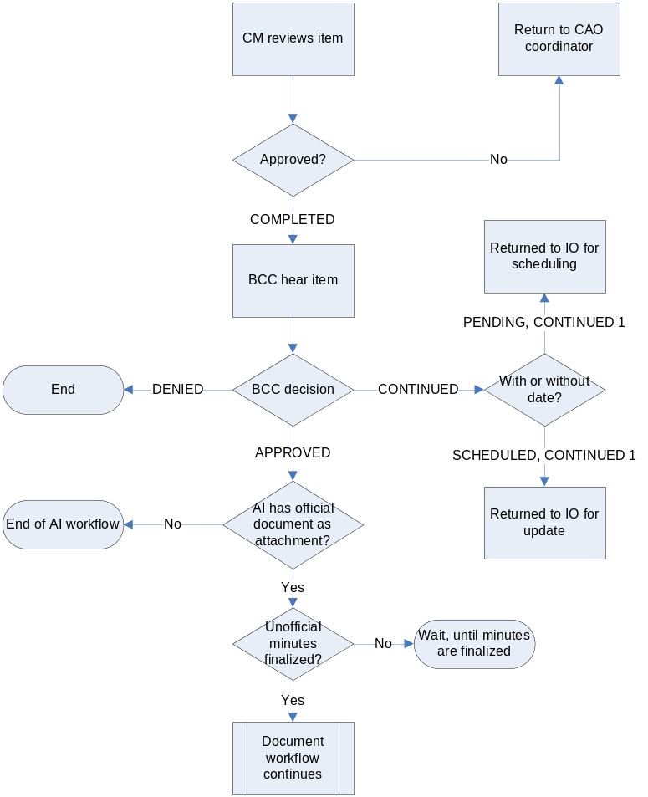

Agenda Memorandum Enhancements (Priority 1)
The Staff Recommendation portion of the agenda memorandum will be optional. IO will be able to enter his/her recommendations and these recommendations could be modified along the agenda review process by any reviewer.

(FOR THE NEXT VERSION) The system will keep history of who made the change and the date that was done.

Save item (Completed. Requirement documentation to be done in future)

Request schedule (Completed. Requirement documentation to be done in future)

Associate item to a project process (Completed. Requirement documentation to be done in future)

Non-project agenda items (Completed. Requirement documentation to be done in future)

Attach documents: (Completed. Requirement documentation to be done in future)

Attach documents Enhancements: (Priority 1)
The Project portion should enforce users to attach required attachments to the processes. Required attachments that are not attached should be always displayed and user should be reminded about it.

Attach documents Enhancements: (FOR THE NEXT AGENDA VERSION-CR)

300-feet notice (FOR THE NEXT AGENDA VERSION-CR)

Description:
The Seminole County’s land development code requires notifying the appropriate property owners of properties located within three hundred (300) feet of the subject property, for which the agenda item is, requested (300 ft notices are associated to a project types, meaning that any item for those projects type will always require a 300 ft. notice). All such project types are presented at the Public Hearing portion of BCC meetings. This module will create the 300’ notice letter (text and map), the 300’ notice mailing list (text), enter the 300’ notice proof (digital confirmation. Confirmation is a way of showing that the notice letter was sent to the property owners of properties located within 300 feet of the new project. Information should be entered by the responsible person after he/she generated the mailing list and sent out the notice letter), and send notification when the 300’ notice is due or late (Criteria to use: send out notices 2 weeks prior to the Public Hearing. System should notify the item originator when this time is approaching) 300’ notice is not related to the building permit. It is related to rezone and/or land use changes, or other changes that will take place after decision made during the Public hearing of the BCC. It is required by law that people should have influence over the decision that can change status of their property. The Agenda 300-feet notice provides a mechanism for such decision. The 300-feet notice allows people to know, what decision the BCC will make over their property, and influence it, by providing written statements or by coming to the hearing.

Business Requirements:
- There will be a confirmation screen to officially report to the system that the 300 feet notice was sent by the user on today’s date.
- User will select a project type or multiple projects and the system will provide different descriptions for the different types of notices (see Appendix 1 to see notices based on project type).
- To obtain the list of customers’ addresses within the 300’ range, the authorized staff member will have access to the GIS system, and with the subdivision name, project name, or another criteria (shape of the actual site after legal is read and site determined/created, not parcel, subdivision, project name or anything else), the system will generate the mailing list within the 300’ range of a particular parcel entered by the user. The mailing list screen for sending the 300’ notice letters will enable users to save, print, and finalize the notice letters (Finalize means that the user is confirming that the information is final and wants to make no further change to the letter. System should disable the edit function to prevent any further change to the notice letters.)
- The system will guarantee that no further change can be made after the user finalizes the 300’ notice letter. User will be able to print the notice letter in legal size paper.
- Not all pubic hearings require the 300' notice. Certain types of projects do not need the 300’ notice procedure. The requirements for the 300’ feet notice is based on the project type (See Appendix 1 for details)
- Notice proof must be entered 2 weeks prior to the BCC public hearing.
- System will provide notifications when the 300’ notice is late (Refer to the specifications in the Notification portion for details)
i) 300 feet Notice Confirmation: This is a confirmation screen to officially report to the system that the 300 feet notice was sent by the user on today’s date. No further change can be made.
ii) 300 feet Notice Letter: This is the actual notice letter. The notice letter is in legal size paper. There are different descriptions for different types of notice letters. User will select a process and the system should bring up the appropriate description for that process. The type of project, applicant, and project description fields will be pull from the application database. Senior Technician should be able to specify date, time, and location. The information layout format should include: Public Hearing Information, Date, Time, and Location. Users will be able to save the notice letter.
iii) 300 feet Notice Mailing: This screen shows the mailing list for sending 300-feet notice letters. System will allow users to save, print, and finalize the notice letter. Currently, the list of addresses is generated by the G.I.S. staff. When the planner sends a request to G.I.S. for the maps for a particular project, the G.I.S. staff creates the address list as a dbf, and then saves it as xls. Currently, the address list is placed on the network for the Planning staff to create the mail out via .xls and Word mail merge. When users go into the GUI to generate the 300 notices, the addresses are listed under the project name.
iv) 300 feet Notice Search: To create or view the notice letter, mailing list, and enter the proof of notice.
(a) Create and View- If project already has a notice letter or mailing list created, then search results return project title with “view” buttons.
(b) Enter - If there is no any notice letter, mailing list or proof of publication, buttons should show:
(i) Project Title – By clicking on this link, the system will provide all information associate with a particular project.
(ii) Agenda item – By clicking on this link, the system will provide all information associate with a particular agenda item.
If project do not have notice letter created, then search results return project title with “Create” buttons.
If there is no proof of notice, the button should show: “enter” for users to input information associate with proof of notice.
The system will provide all information associate with a particular project. If project already has notice letter or mailing list created, then search results return project title with “view” buttons.

Following table presents statuses of the 300’ notice workflow. Statuses are displayed on the workflow schema in capital letters.

300-feet notice statuses table

Status | Description
300’ notice is not entered | Process of 300’ notice is not started yet for this particular agenda item, but it is required
Not applicable | 300’ notice is not required for this item
300’ notice is created | Item originator/administrative staff created 300feet notice letter or mailing list
Proof of 300’ notice is entered | Proof of 300-ffet notice is being entered by IO to the system

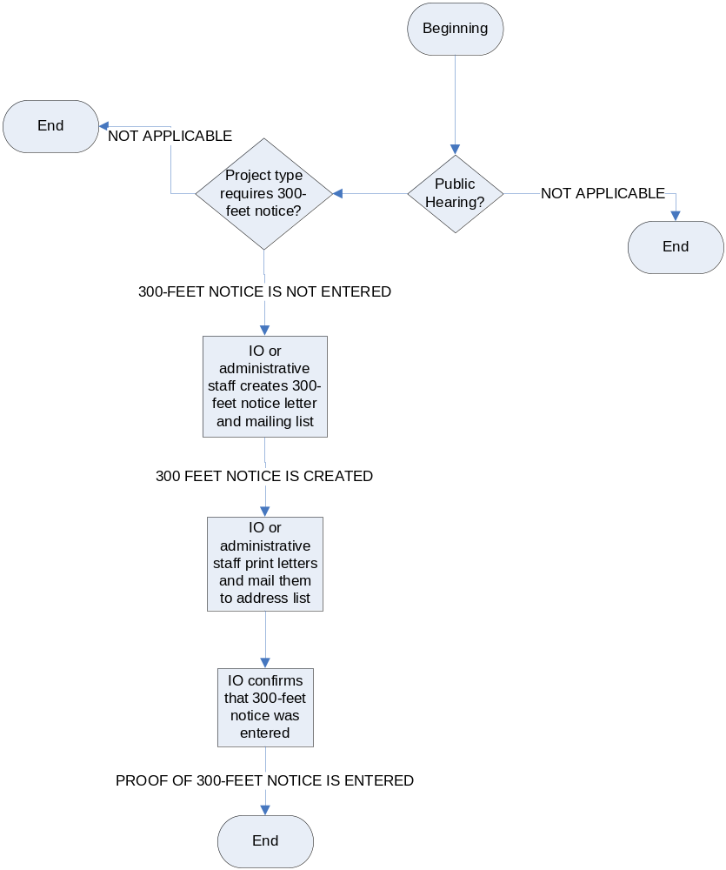300-Feet Notice Workflow:

Proof of publication (FOR THE NEXT AGENDA VERSION-CR)

Description
The Seminole County’s land development code requires placing advertisements of public hearings of property, for which the agenda item is requested, over the newspaper. The proof of publication module will create legal ad, both map and text and send it to the Orlando Sentinel to publish in the newspaper. Users will be able to enter the proof of publication and search for existing proof of publications in the system. It is required by law that people should have influence over the decision that can change status of their property. Same as the 300 feet notice, it allows people to know what decision the BCC will make over their property and influence it by providing written statements or by coming to the hearing.

Business Requirements
- Users will be able to search for existing proof of publications.
- The system will route the legal ad to specified reviewers (currently, Senior Engineer).
- The system will notify the users when the proof of publication is due or if it is late (Refer to the specifications in the Notification portion for details)
- If the project already has the notice letter or the mailing list created, then the search results will return the project title and the agenda subject with “view” buttons. By clicking on this link, the system will provide detail information associated with the particular project and the agenda item.
- If the agenda item requests a change that will affect the entire County, such as mailing notice letter to all the residences in Seminole County, the proof of publication will have a legal ad associated with.
- The proof of publication review screen will provide a function that will allow the users to send the proof of publication to a newspaper through the system.
- The system will keep a record on all the proof of publications created or sent to the Orlando Sentinel (newspaper).
- The system will provide a function that allows user to send a proof of payment (fee invoice) back to the newspaper.
- The system will keep track of the fee invoice returned by the Orlando Sentinel to proceed with the payment.
- The system will have a function that allows users to receive digitally proof of publication accepted for the CM’s office.
- User will be able to print the proof of publication notice.
- Proof of Publication must be entered 2 weeks prior to the BCC public hearing.

The following table presents statuses of the proof-of-publication workflow. Statuses are displayed on the workflow schema in capital letters. The proof of publication workflow follows the same schema as the agenda item to which it belongs to (i.e. the team leader for current planning reviews proof of publication for agenda item related to current planning, etc).
Proof of publication statuses table:

Status | Description
Publication: not entered | Process of publication is not started yet for this particular agenda item but it is required
Not applicable | Process of publication is not required for this item
Publication text is created | Item originator/administrative staff created text of publication and/or downloaded necessary map
Publication: review of team leader 1 | Text of publication is under review of team leader for the first time
Publication: returned by team leader 1 | Text of publication is being returned by team leader for the first time
Publication: review of assistant division manager 1 | Text of publication is under review of assistant division manager for the first time (planning only)
Publication: returned by assistant division manager 1 | Text of publication is being returned by assistant division manager for the first time (planning only)
Publication: review of division manager1 | Text of publication is under review of division manager for the first time
Publication: returned by division manager1 | Text of publication is being returned by division manager for the first time
Publication text is approved | Text is being approved by all reviewer
Publication text is submitted to the newspaper | Text is being submitted to the newspaper by IO
Proof of publication is entered | Proof of publication is being entered by IO to the system
Proof of Publication Workflow:

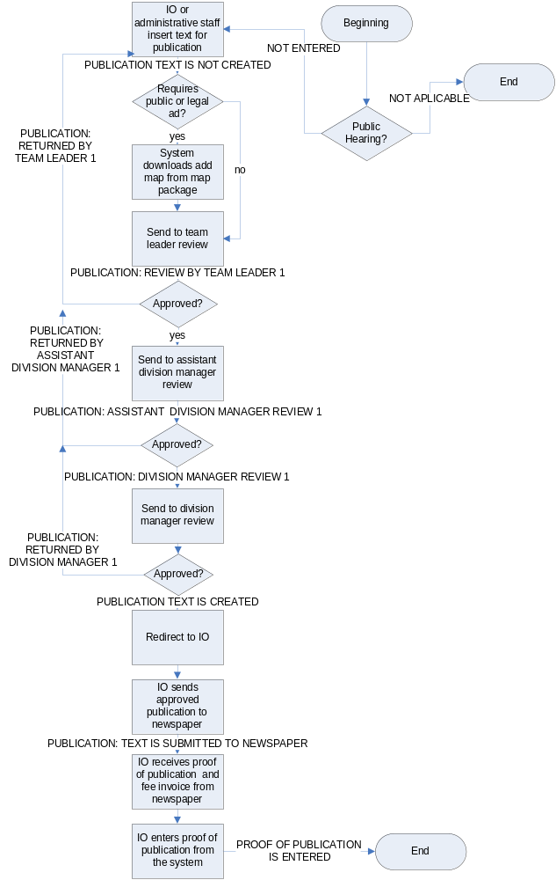

Placard (FOR THE NEXT AGENDA VERSION-CR)

Description
The Seminole County’s land development code requires notifying the public and the appropriate property owners about changes in the property, for which the agenda item is requested. This module will be able to create placard display, both map and text, placard affidavit, and notify the user when placard is due or late (See Business Requirements item 6 below). This module is related to the land use change or other changes that will take place after the decision is made during the Public hearing by the BCC. It is required by law that people should have influence over decision that can change status of their properties. The Agenda application provides mechanism for such decision. It allows people to know what decision the BCC will make over their properties, and influence it by providing written statements or by coming to the hearing.

Business Requirements
- The system will guarantee that no further changes will be made after the placard is being finalized (Finalize means that the user is confirming that the information is final and no further changes to the letter will be allowed. System should disable the edit function to prevent any further change to the notice letter. After the Public Hearing, no more changes will be allowed)
- Users will be able to print the placard letter and the placard affidavit in letter size paper (this will include Notification, map, Public hearing information, and contact information)
- Users will be able to print the placard display in legal size paper.
- There will be a confirmation screen to officially report to the system that the placard letter, the placard display or the placard affidavit was sent by the user on today’s date.
- Users will be able to search for existing placard letters, placard display or placard affidavits.
- The system will notify users, when a placard letter, a placard display or a placard affidavit is due/late.
- Placard affidavit is due to the CM office in 3 days (17 days prior to BCC meeting)
- Placard affidavit is due to the CM office (14 days prior to BCC meeting)
- Placard affidavit is late to the CM office (less than 14 days prior to BCC meeting)
- If the project already has a placard letter, a placard display or a placard affidavit created then, the search results will return the project title and the agenda subject with “view” buttons. By clicking on this link, the system will provide detail information associated with the particular project and the agenda item.
- Users will be able to print placard letters, placard display, or placard affidavits.
- Signed placard affidavit will be entered at least 2 weeks prior to the BCC public hearing.

The following table presents statuses of the placard workflow. Statuses are displayed on the workflow schema in capital letters.

Placard statuses table:

Status | Description
Placard: is not entered | Process of placard is not started yet for this particular agenda item, but it is required
Not applicable | Placard is not required for this item
Placard is created | Item originator/administrative staff created placard letter or placard display or placard affidavit
Proof of placard posting is entered | Placard affidavit is being entered by IO to the system
Placard Workflow:
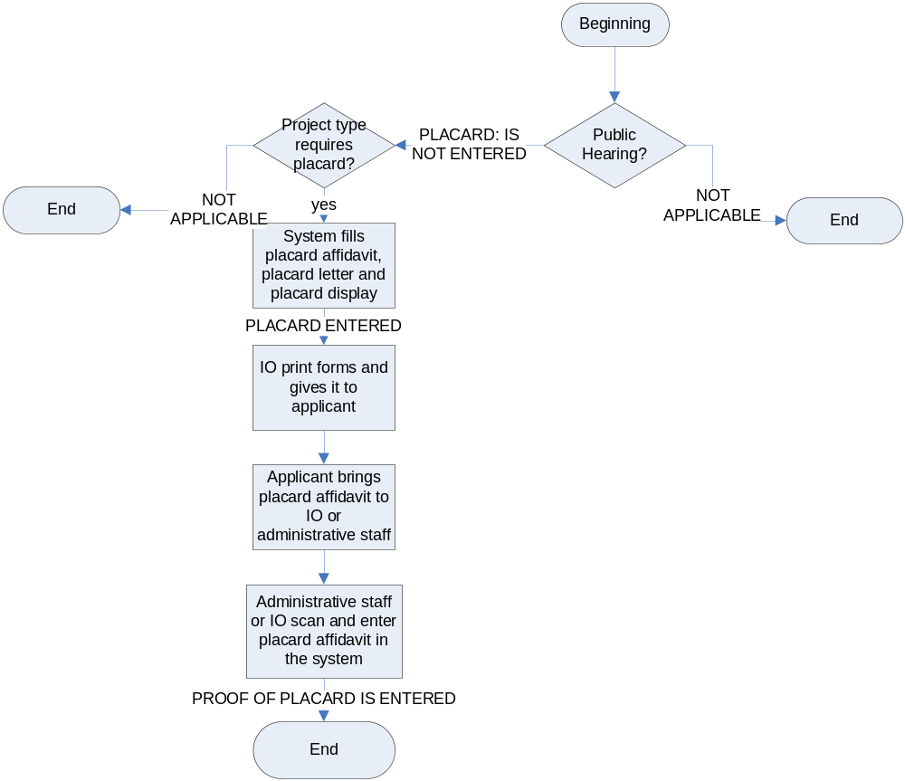

Associate item to a project process (Completed. Requirement documentation to be done in future)

Non-project agenda items (Completed. Requirement documentation to be done in future)

Update item (Completed. Requirement documentation to be done in future)

Inbox: (Priority 1)

Request schedule (Completed. Requirement documentation to be done in future)

Request reschedule (Completed. Requirement documentation to be done in future)

Send for review (Completed. Requirement documentation to be done in future)

Hold item (Completed. Requirement documentation to be done in future)

Withdraw item (Priority 1)
The item originator should be able to withdraw an agenda item. Item can be withdrawn at any time of the review process once the item has been rejected along the process. When the agenda item has been withdrawn, its workflow will be removed completely from the review process. When an item is withdrawn, notifications are sent to particular users (Refer to specifications in the Notification portion for details)

(FOR THE NEXT VERSION OF THE AGENDA APPLICATION-CR) Some other reviewers such as team leader, assistant division manager, and division manager will also be able to withdraw items at any time of the review process.

Save item (Completed. Requirement documentation to be done in future)

Search/Advance Search: (Completed. Requirement documentation to be done in future)
    - Review item status
    - Review item history
      - Review detail Project information
      - Review detail agenda item

Agenda Item Enhancements (Priority 1)
- The Agenda template, that the item originator uses, should be set up in the correct format and correct font by the system.
  - For the Agenda Memorandum:
    - Seminole County Government: Arial, 12 font Bold.
    - Agenda Memorandum: Arial, 12 font Bold and Italic.
    - Subject: Arial, 12 font for content and Capitalized Bold label.
    - Department: Arial, 12 font for content and Capitalized Bold label.
    - Division: Arial, 12 font for content and Capitalized Bold label.
    - Authorized by: Arial, 12 font for content and Capitalized Bold label.
    - Contact: Arial, 12 font for content and Capitalized Bold label.
    - Ext: Arial, 12 font for content and Capitalized Bold label.
    - Agenda Date: Arial, 12 font for content and Bold labels.
    - Motion/Recommendation: Arial, 12 font for content and Capitalized Bold label.
    - Background: Arial, 12 font for content and Capitalized Bold label.
    - Staff Recommendations: Arial, 12 font for content and Capitalized Bold label.
    - Reviewed by: Arial, 9 font for content and Bold label. This box must always appear on the bottom right corner of the first page of the agenda memorandum.

  - For the Agenda Standard Report:
    - SEMINOLE COUNTY
BOARD OF COUNTY COMMISSIONERS
AGENDA
DAY, MONTH DATE, YEAR
COUNTY SERVICES BUILDING
BCC CHAMBERS – ROOM 1028
1101 EAST FIRST STREET
SANFORD, FLORIDA
Arial, 12 font for content and Capitalized Bold label.
    - Convene BCC Meeting at 9:30 A.M.: Arial, 14 font Bold
    - Opening Ceremonies: Arial, 14 font Bold
- Invocation: Arial, 14 font Bold
- Pledge of Allegiance: Arial, 14 font Bold
    - Awards and Presentations: Arial, 14 font Bold
    - Consent Agenda: Arial, 14 font Bold
- County Manager’s Consent Agenda (Items No.): Arial, 14 font Bold
    - FROM HERE DOWN ALL THE DEPARTMENTS ARE INCLUDED IN ALPHABETIC ORDER AND THEY ARE ARIAL, 12 FONT BOLD.
    - UNDER EACH DEPARTMENT, ALL DIVISIONS AND SECTIONS WILL BE ARIAL, 12 FONT BOLD AND ITALIC.
    - MOTION AND CONTENT ARE ARIAL, 12 FONT
    - IF THE DIRECTOR OF THE DEPARTMENT IS PRENSENTING ITEMS THEY WILL BE MENTIONED BY THE DEPARTMENT NAME AS ARIAL, 12 FONT.
    - ON TOP OF EACH PAGE EXCEPT FOR THE FIRST ONE, THE FOLLOWING NEEDS TO BE INCLUDED:
BCC Agenda
Month Date, Year
Page #
    - County Attorney’s Consent Agenda (Items No.): Arial, 14 font Bold
    - Litigation: Arial, 12 font Bold and Italic
    - Property Acquisition: Arial, 12 font Bold and Italic
    - Constitutional Offices Consent Agenda (Items No.): Arial, 14 font Bold
- Clerk’s Office Arial, 14 font Bold (Maryanne Morse, Clerk of the Court) Arial, 14 font
- Sheriff’s Office Arial, 14 font Bold (Don Eslinger, Sheriff) Arial, 14 font
- Regular Agenda: Arial, 14 font Bold
- County Manager’s Briefing: Arial, 14 font Bold
- County Attorney’s Briefing: Arial, 14 font Bold
- Recess BCC Meeting until 1:30 P.M.: Arial, 14 font Bold

- Reconvene BCC Meeting until 1:30 P.M.: Arial, 14 font Bold
- Public Hearing Agenda: Arial, 14 font Bold
- Accept Proofs of Publication: Arial, 14 font Bold
- Chairman’s statement of Public Hearing Rules and Procedures: Arial, 14 font Bold
    - Public Hearings: Arial, 14 font Bold
- Legislative Update: Arial, 14 font Bold
    - Chairman’s Report
    - District Commissioner’s Report – District 5, 1, 2, 3, and 4: Arial, 14 font Bold
    - Committee Reports: Arial, 14 font Bold
    - County Manager’s Report: Arial, 14 font Bold
    - Items for future Agenda – Commission, Staff, or Citizens: Arial, 14 font Bold
    - Adjourn BCC Meeting: Arial, 14 font Bold
    - ON THE LAST PAGE:
PERSONS WITH DISABILITIES NEEDING ASSISTANCE TO PARTICIPATE IN ANY OF THESE PROCEEDINGS SHOULD CONTACT THE HUMAN RESOURCES DEPARTMENT, ADA COORDINATOR 48 HOURS IN ADVANCE OF THE MEETING AT 407-665-7941 (Arial, 14 font Capitalized)

FOR ADDITIONAL INFORMATION REGARDING THIS NOTICE, PLEASE CONTACT THE COUNTY MANAGER’S OFFICE, AT 407-665-7219. PERSONS ARE ADVICED THAT, IF THEY DECIDE TO APPEAL DECISIONS MADE AT THESE MEETINGS / HEARINGS, THEY WILL NEED A RECORD OF THE PROCEEDINGS AND FOR SUCH PURPOSE, THEY MAY NEED TO INSURE THAT A VERBATIM RECORD OF THE PROCEEDINGS IS MADE, WHICH INCLUDES THE TESTIMONY AND EVIDENCE UPON WHICH THE APPEAL IS TO BE BASED, PER SECTION 286.0105, FLORIDA STATUTES. (Arial, 14 font Capitalized)

- The main agenda page should provide the ability for all reviewers and the item originator to track changes in the main fields of agenda memorandum. There are 3 main types of editing that can be tracked by users: change of selected option in drop-down menu fields; insertion of text, and deletion of text in the text fields. Edited field (both text and drop-down) should be displayed in the different color (i.e. red or blue) in order to point to the viewer that editing was made by other user. In a separate pop-up window user should be able to view following information about editing:
- Type of editing (change, insertion or deletion)
- Name of user, who made editing of the text
- Status of agenda item, when editing was made (i.e. “review of team leader 1”)
- Date and time, when editing was made
- Text of editing (i.e. for changes: “changed from development review” to “community resources”)
Information about editing should be displayed only for authorized viewers. External customers should be provided with only “view” options. All text fields in the agenda memorandum (agenda subject, motion/recommendation, background, staff recommendation) should have a default spell check capability. These specifications do not apply to the text of attached files.
- (FOR THE NEXT VERSION OF THE AGENDA APPLICATION-CR) The item originator and some particular reviewers should be able to add special conditions to the agenda item (user decides whether add or remove condition to the agenda item on individual basis). Such conditions are mostly related to the activities of external customers. They may influence agenda items when it is heard by the BCC, but they do not preclude item originators from starting the agenda review process. A common example of a condition is receiving a particular permit by an external user prior to the BCC hearing date. Conditions should be entered by users as text and should be displayed to every consecutive reviewer. Conditions should be usually met, when the agenda item is entering by the assistant of DCM/CM for final review. The team leader, the assistant division manager, and the division manager should be able to withdraw conditions or place new conditions on agenda items. Multiple conditions per each agenda item are allowed. Item originators or other users, who placed condition on agenda item, can at any time enter proof in the system that a condition was met. If a condition is not met by the time when the agenda item is routed to the system to the assistant’s of DCM/CM for review, its’ further movement is blocked. In such case, item originators or users, who placed conditions should either reschedule or withdraw the agenda item. Notifications are sent to specified users about conditions. (Refer to specifications in the Notification portion for details.)
- (FOR THE NEXT VERSION OF THE AGENDA APPLICATION-CR) For every type of agenda process (See Appendix 2) system should display standard wording for fields: “motion/recommendation”, background” and “staff recommendation”. Such wording should be provided by the Seminole County staff for each division. If a division does not have standard wording or does not provide standard wording for the agenda system, discussed fields will remain empty, when new agenda item is created.
- (FOR THE NEXT VERSION OF THE AGENDA APPLICATION-CR) When creating an agenda item, the item originator should be able to view the agenda items of the processes associated with the selected project. If the agenda items of the same process/project were created by the same user, the item originator will have full permissions towards such projects. Otherwise, IO can only view details of such projects/items. For instance, if the selected project has four processes and the IO selects only two of those processes, the system will display the agenda items for each of these two processes. Also, it will display the agenda items related to the processes no selected under a heading named “Others”.
- (FOR THE NEXT VERSION OF THE AGENDA APPLICATION-CR) Item originator should be able to link newly created items with existing items in the agenda system. System should prompt users if he/she would like to link agenda items, if there are agenda items associated with the same project. User can choose to link these items or any other existing item in agenda system. When two agenda items are linked, memo page for each item should display hyperlink to connected items. Authorized users (TL, ADM, and DM) can remove connection established between two items. More than 2 items can be connected at the same time

Required Attachments
- (FOR THE NEXT AGENDA VERSION-CR) System should block sending agenda items for review, when no required attachments are attached (Refer to Appendix 2 for details of required attachments). Authorized users (team leaders, assistant division managers and division managers) should be able to waive required attachment condition for a particular agenda item.
- (FOR THE NEXT AGENDA VERSION-CR) System should be able to identify required maps that are considered agenda items’ attachments from the shared location in Seminole County (map packages).

Inbox (Priority 1)
  - In addition to existing columns, the inbox should contain the following extra columns: item originator, users whom item was received from, and BCC date.
  - User should be able to access the details of a project from the hyperlink “project name”.
  - (FOR THE NEXT AGENDA VERSION-CORE GROUP) Implementation of Outlook: Agenda items, proof of publications and documents (and any other independently routed articles) should be placed in different folders of the inbox.
  - (FOR THE NEXT AGENDA VERSION-CORE GROUP) Users should have control over the creation of new, editing and deleting existing folders within the inbox. User should also be able to move workflow articles from one folder to another.
  - (Completed in Version 1) Hyperlink to the agenda status should display the agenda status detail table. Agenda status detail table should contain the following information:
- Agenda subject (as title),
- For each user in the workflow starting with the item originator and finishing with the CM:
- User’s name,
- Users e-mail address,
- Status that AI had at this time,
- Action taken toward AI in accordance with the statuses table (Appendix 3),
- Label pointing to the existence of comment,
- Start date and time for action taken,
- End date and time for action take

Search: (Priority 1)
      - The Main search page should have references to the search engines for: documents, the BCC report (agendas), 300-feet notice documents, placards, proof of publications, the unofficial BCC minutes, and the official BCC minutes. These search engines should be different from the one that are used by the assistant DCM/DC. They should only display finalized search products (finalized agendas, unofficial and official minutes). Search engines should be usable for both internal and external customers.
      - The Search engine for the BCC minutes should search by minutes’ type and BCC date options. This Search results should be sorted as default by BCC date as criteria (ascending order: the most current on top).
      - The Search engine for the BCC report (agenda) should search for agendas by the BCC date. The Search results should be sorted by BCC date as default criteria (ascending order: the most current on top.
      - All search results that are going to be implemented in this version should be printable.
      - (FOR THE NEXT VERSION OF THE AGENDA APPLICATION-CR) The Search engine for documents should search for documents by the following criteria: document type, document number, text in document title, agenda subject text, agenda item’s BCC date, item originator, division, department, and district. The Search results should display the following columns: document title, document type, document number (if any) agenda subject, agenda item BCC date, division, department, districts, and item originator. The Search results should be sorted by default using BCC date is criteria (ascending order: the most current on top). Each column will be sortable.
      - (FOR THE NEXT AGENDA VERSION-CR) Search engine for the 300-feet notice should search for the 300-feet notices (letters and list) by following criteria: BCC date, agenda subject text, division, department, districts, and item originator. The Search results should display the following columns: agenda subject, BCC date, division, department, districts, 300-feet notice’s status, and item originator. Each column can be used for re-sorting the documents searched. The Search results should be sorted by default using the BCC date as criteria (ascending order: the most current on top).
      - (FOR THE NEXT AGENDA VERSION-CR) The Search engine for placard should search by following criteria: BCC date, agenda subject text, division, department, districts and item originator. The Search results should display the following columns: agenda subject, BCC date, division, department, districts, placard’s status and item originator. Each column can be used for resorting of document search. The Search results should be sorted by default using the BCC date as criteria (ascending order: the most current on top).
      - (FOR THE NEXT AGENDA VERSION-CR) The Search engine for proof of publication should search by following criteria: BCC date, agenda subject text, division, department, districts, and item originator. The Search results should display the following columns: agenda subject, BCC date, division, department, districts, publication’s status and item originator. Each column can be used for resorting the document searched. The Search results should be sorted by default using BCC date as criteria (ascending order: the most current on top).
      - (FOR THE NEXT AGENDA VERSION-CR) All search results should be able to be exported to Access and/or other software for report purposes only. The Excel exported capability has been already implemented in this version 1.
      - (FOR THE NEXT AGENDA VERSION-CR) All search results that are going to be implemented in the next version should be printable (print preview).

Agenda item schedule request administration: (Completed. Requirement documentation to be done in future)

Inbox (Complete Requirements documentation to be done in future)
  - Approve schedule request
  - Reject schedule request

Search (Complete Requirements documentation to be done in future)

Tracking sheet: (Complete Requirements documentation to be done in future)
  - Review all scheduled agenda item status
  - Review all scheduled detail agenda item

Award and Presentation Report Items (Complete Requirements documentation to be done in future)
1. Create Award and Presentation
2. Attach documents
3. Update Award and Presentation
4. Delete Award and Presentation

Miscellaneous Report Items (Complete Requirements documentation to be done in future)
1. Chairman report:
          - Add
          - Attach documents
          - Delete
          - Update
2. Committee report:
          - Add
          - Attach documents
          - Delete
          - Update
      - County Manager report
          - Add
          - Attach documents
          - Delete
          - Update
      - District Commissioners report
          - Add
          - Attach documents
          - Delete
          - Update
      - Items for future agenda
          - Add
          - Attach documents
          - Delete
          - Update

Workflow: (Priority 1)

Planning and Development Department (Priority 1)

Development Review Division (Completed. Requirement documentation to be done in future)

Building Division (Priority 1)
This module describes the new workflow schema for the review of the agenda items created within the Building division. All the agenda items follow the same workflow in this division. There are only three (3) authorized users, item originator, deputy building official (assistant division managers), and one building official (division manager). Once the agenda items are being created and reviewed within the Building division, it follows the regular workflow as any other agenda item. Agenda items have the same statuses as any other divisions’ agenda items. On the workflow schema agenda statuses are capitalized.

Detailed workflow:
(FOR THE NEXT AGENDA VERSION-CORE GROUP) The Agenda project types included in this group are all the Building division projects:

- Amendment to building code,
- Appeal of building board decision,
- Appeal of mechanic board decision,
- Appeal of swimming pool board decision;
- Appeal of plumbing board decision,
- Appeal of electric board decision,
- Appeal of drilling board decision,
- Flood mitigation assistance agreement, and
- Miscellaneous

Detailed workflow from the item originator to the assistant of department director:

Position of item originator | Name of item originator | Detailed workflow for agenda item
Deputy building official | Jim Stroupe | 1st reviewer - Larry Goldman  ( building official)
Deputy building official | Tom Helle | 1st reviewer - Larry Goldman  ( building official)
Building official | Larry Goldman | None

Building Division Agenda Process Workflow:
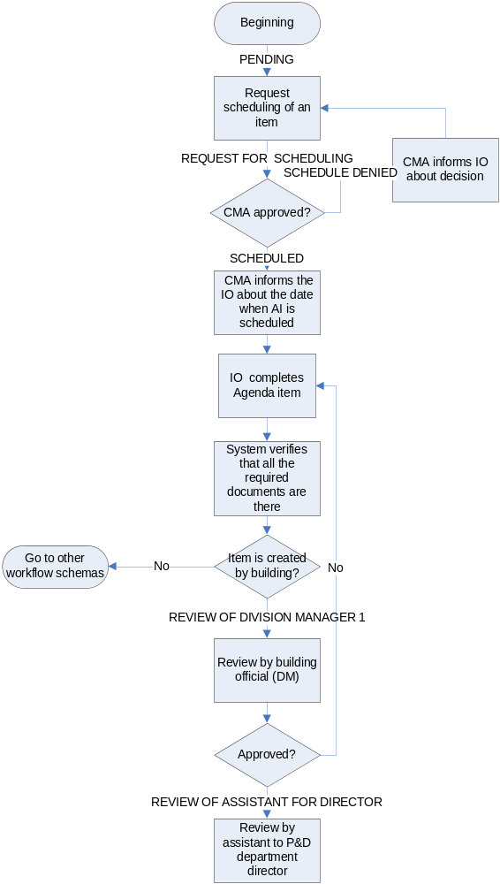

Community Resources Division (Priority 1)
This module describes the new workflow schema for reviewing agenda items created within the Community Resources division. There are two different groups of agenda items within Community Resources: CSI and Natural Lands. The Addressing section (under CSI) agenda items and the Natural Lands agenda items have similar workflow: they are being reviewed by the team leaders of these groups first, and then by the division manager. CSI, GIS, and Imaging items are being reviewed only by the division manager. Miscellaneous items should follow the workflow of the group to which the item originator belongs. If item originator belongs to multiple agenda groups, the agenda system should question IO before agenda item is sent to the review process, to which group the item belongs. Once the agenda item is being created and reviewed within the Community Resources division, it follows the regular workflow as any other agenda item within the Planning and Development Department. The agenda items have the same status as any other divisions’ agenda items. On the workflow schema agenda statuses are capitalized.

Detailed workflow:
(FOR THE NEXT AGENDA VERSION-CORE GROUP) The Agenda project types included in the Addressing agenda items group are (items created by users, who are item originators within the Addressing group):
  - Street name change
  - Miscellaneous

Position of item originator | Name of item originator | Detailed workflow for agenda item
Technician | Amy Curtis | 1st reviewer - Maggie Ketcham  (Sr. coordinator)  2nd reviewer - Colleen Rotella  (Community Resources division manager)
Technician | Patti Branchi | 1st reviewer - Maggie Ketcham  (sr. coordinator)  2nd reviewer - Colleen Rotella  (Community Resources division manager)
Technician | Joy Williams | 1st reviewer - Maggie Ketcham  (sr. coordinator)  2nd reviewer - Colleen Rotella  (Community Resources division manager)
Sr. coordinator | Maggie Ketcham | 1st reviewer - Colleen Rotella  (Community Resources division manager)
Community Resources division manager | Colleen Rotella | None

(FOR THE NEXT AGENDA VERSION-CORE GROUP) The Agenda project types included in the Natural Lands agenda items group are (items created by users, who are item originators within the Natural Lands group):
  - Miscellaneous
Position of item originator | Name of item originator | Detailed workflow for agenda item
Principal Coordinator | Amy Raub | 1st reviewer - Jim Duby  (Program Mgr Natural Lands)  2nd reviewer - Colleen Rotella (Community Resources division manager)
Program Mgr Natural Lands | Jim Duby | 1st reviewer - Colleen Rotella  (Community Resources division manager)
Division Mgr Community Resources | Colleen Rotella | None

(FOR THE NEXT AGENDA VERSION-CORE GROUP) The Agenda project types included in the GIS Imaging agenda items group are (items created by users, who are item originators within the GIS and Imaging groups):
1. Miscellaneous

Position of item originator | Name of item originator | Detailed workflow for agenda item
Principal imaging coordinator |  | 1st reviewer - Colleen Rotella  (Community Resources division manager)
Division Mgr Community Resources | Colleen Rotella | None

(FOR THE NEXT AGENDA VERSION-CORE GROUP) The Agenda project types included in the CSI agenda items group are (items created by users, who are item originators within the CSI group):
      - Miscellaneous

Position of item originator | Name of item originator | Detailed workflow for agenda item
Program Manager CSI | Jackson Heinzelman | 1st reviewer - Colleen Rotella  (Community Resources division manager)
Division Mgr Community Resources | Colleen Rotella | None

Community Resources Agenda Process Workflow:

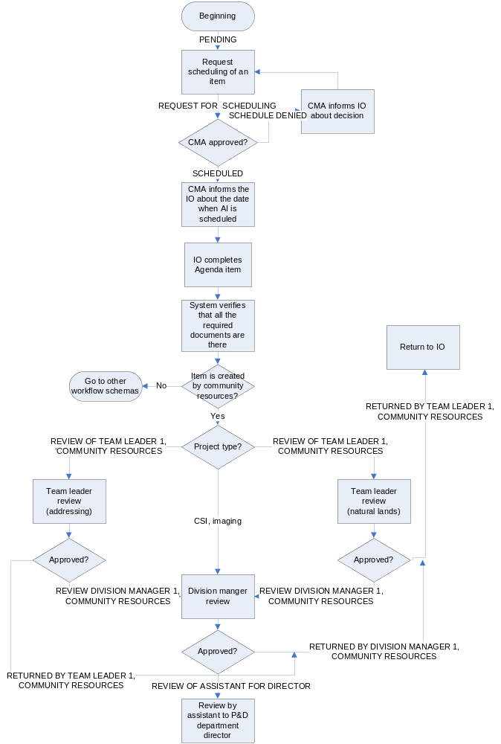

Planning and Zoning Division (Priority 1)
This module describes the new workflow schema for reviewing agenda items created within the Planning division. There are 4 different groups of agenda items within the Planning division: current planning, long range, administrative, and BOA. Each of these agenda items’ groups has similar workflow: item is being reviewed by the team leader (supervisor), then by the assistant planning manager, and the planning manager. Board briefing items should follow the workflow of the group to which the item originator belongs. If the item originator belongs to multiple agenda groups, the agenda system should question IO before agenda item is sent to the review process, to which group the item belongs to. Once the agenda items is being created and reviewed within the Planning division, it follows the regular workflow as any other agenda item. Agenda items have the same status as any other divisions’ agenda item. On the workflow schema agenda statuses are capitalized.

Detailed workflow:
(FOR THE NEXT AGENDA VERSION-CORE GROUP) The Agenda project types included in the current Planning agenda items group are (items created by users who are item originators within current planning group):
- Straight rezone without site plan
- Rezone with site plan to - PUD, PCD, OP, RP, RM-2, RM-3, R-3, R-3A, R-4
- PUD/PCD Major Amendment
- PUD Final Master Plan
- PCD Final Site Plan
- Small Scale F L U A with no Rezone
- Small Scale F L U A and Straight Rezone
- Small Scale F L U A with site plan Rezone
- Large Scale F L U A - Transmittal hearing with no Rezone
- Large Scale F L U A - Adoption hearing with no Rezone
- Large Scale F L U A Transmittal hearing with Straight Rezone
- Large Scale F L U A Adoption hearing with Straight Rezone
- Large Scale F L U A Transmittal hearing with site plan Rezone
- Large Scale F L U A Adoption hearing with site plan Rezone
- Board briefing

Detailed workflow from item originator to assistant of department director:

Position of item originator | Name of item originator | Detailed workflow for agenda item
Sr. planner | Mike Rumer | 1st reviewer – Tina Williamson (principle planner)  2nd reviewer - April Boswell  (Assistant planning manager)  3rd reviewer - Tony Walter  (Planning division manager)
Sr. planner | Ben Dunn | 1st reviewer – Tina Williamson (principle planner)  2nd reviewer - April Boswell  (Assistant planning manager)  3rd reviewer - Tony Walter  (Planning division manager)
Coordinator | Connie | 1st reviewer – Tina Williamson (principle planner)  2nd reviewer - April Boswell  (Assistant planning manager)  3rd reviewer - Tony Walter  (Planning division manager)
Assistant planning manager | April Boswell | 1st reviewer – Tony Walter
Planning division manager | Tony Walter | None

(FOR THE NEXT AGENDA VERSION-CORE GROUP) The Agenda project types included in the long range agenda items group are (items created by users, who are item originators within long range group):
- Dev Regional Impact (DRI)
- Small Scale F L U A with no Rezone
- Large Scale F L U A - Transmittal hearing with no Rezone
- Large Scale F L U A - Adoption hearing with no Rezone
- Large Scale F L U Text Amendment
- LDC Amendment
- Board briefing
- Small Scale F L U A and Straight Rezone
- Small Scale F L U A with site plan Rezone
- Large Scale F L U A Transmittal hearing with Straight Rezone
- Large Scale F L U A Adoption hearing with Straight Rezone
- Large Scale F L U A Transmittal hearing with site plan Rezone
- Large Scale F L U A Adoption hearing with site plan Rezone

Position of item originator | Name of item originator | Detailed workflow for agenda item
Sr. planner | Dick Boyer | 1st reviewer - Sheryl Stolzenberg (principal planner), long range  2nd reviewer - April Boswell  (Assistant planning manager)  3rd reviewer - Tony Walter  (Planning division manager)
Sr. planner | Jeff Hopper | 1st reviewer - Sheryl Stolzenberg (principal planner), long range  2nd reviewer - April Boswell  (Assistant planning manager)  3rd reviewer - Tony Walter  (Planning division manager)
Principal planner | Tom Tomerlin | 1st reviewer - Sheryl Stolzenberg (principal planner), long range  2nd reviewer - April Boswell  (Assistant planning manager)  3rd reviewer - Tony Walter  (Planning division manager)
Principle planner | Tony Matthews | 1st reviewer - Sheryl Stolzenberg (principal planner), long range  2nd reviewer - April Boswell  (Assistant planning manager)  3rd reviewer - Tony Walter  (Planning division manager)
Principal planner | Sheryl Stolzenberg | ^{1st} reviewer - April Boswell  (Assistant planning manager)  2nd reviewer - Tony Walter  (Planning division manager)
Assistant Planning Manager | April Boswell | 1st reviewer – Tony Walter
Planning Division manager | Tony Walter | None

(FOR THE NEXT AGENDA VERSION-CORE GROUP) The Agenda project types included in the BOA agenda items group is (items created by users, who are item originators within long range group):
- BOA Appeals of variances and special exceptions

(FOR THE NEXT AGENDA VERSION-CORE GROUP) The Agenda project types included in the administrative agenda items group is (items created by users, who are item originators within long range group):
    - Code enforcement lien reduction

Position of item originator | Name of item  originator | Detailed workflow for agenda item
Planner | Ian Sikonia | 1st reviewer - Kathy Fall  (Principal planner), BOA  2nd reviewer - April Boswell  (Assistant planning manager)  3rd reviewer - Tony Walter  (Planning division manager)
Sr. planner | Denny Gibbs | 1st reviewer - Kathy Fall  (Principal planner), BOA  2nd reviewer - April Boswell  (Assistant planning manager)  3rd reviewer - Tony Walter  (Planning division manager)
Principal planner | Kathy Fall | ^{1st} reviewer - April Boswell  (Assistant planning manager)  2nd reviewer - Tony Walter  (Planning division manager)
Assistant Planning Manager | April Boswell | 1st reviewer – Tony Walter
Planning Division manager | Tony Walter | None

Planning and Zoning Agenda Process Workflow:

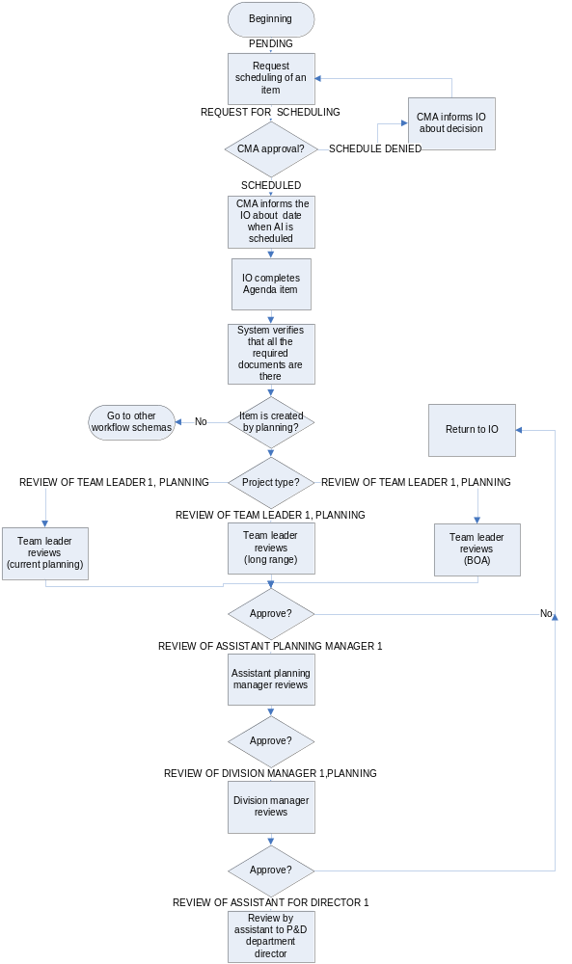

The following information describes the general workflow for the agenda process in other departments at Seminole County. If an agenda user has two different titles or is assuming two different tittles, the system assigns the higher level to the agenda user (i.e. If an agenda user has two titles, Division Manager and Director, the system assigns “Director” to the user).

For this Agenda version, the Agenda system has three organizational levels, Department level, Division level, and Section level. “Division” is a required field. An “administration division” will be added for every Department that has divisions. So if an IO wants an AI to follow the Departmental workflow, the AO must pick the corresponding Department's administration division option. The reason for doing this is the BCC Report. If an item does not have any Division, there is no appropriate place to locate this item in the report.

Detail workflow steps will be collected and included in the next Agenda version document.

Public Safety Department: (Priority 1)
This module describes the workflow schema for reviewing the agenda items created within the Public Safety Department. Following are the different divisions/sections under this Department:
- Animal Services:
- Item Originator creates an agenda item and sends it for scheduling
- Review By item scheduler and Send it back to IO
- IO creates the Agenda Memorandum and Sends it to the review process
- Review By the Division Manager (same as 1st level review)
- Review By Department Director’s Assistant
- Review By Department Director
- Emergency Communications:
- Item Originator creates an agenda item and sends it for scheduling
- Review By item scheduler and Send it back to IO
- IO creates the Agenda Memorandum and Sends it to the review process
- Review By the Division Manager (same as 1st level review)
- Review By Department Director’s Assistant
- Review By Department Director
- Emergency Management:
- Item Originator creates an agenda item and sends it for scheduling
- Review By item scheduler and Send it back to IO
- IO creates the Agenda Memorandum and Sends it to the review process
- Review By 1st level reviewer
- Review By the Division Manager
- Review By Department Director’s Assistant
- Review By Department Director
- EMS Fire Rescue:
- Item Originator creates an agenda item and sends it for scheduling
- Review By item scheduler and Send it back to IO
- IO creates the Agenda Memorandum and Sends it to the review process
- Review By the Division Manager (same as 1st level review)
- Review By Department Director’s Assistant
- Review By Department Director
- Administration:
- Item Originator creates an agenda item and sends it for scheduling
- Review By item scheduler and Send it back to IO
- IO creates the Agenda Memorandum and Sends it to the review process
- Review By The Division Manager (same as 1st level review)
- Review By Department Director’s Assistant
- Review By Department Director

Environmental Services Department: (Priority 1)
This module describes the workflow schema for reviewing agenda items created within the Environmental Services Department. Following are the different divisions/sections under this Department:
      - Business Office:
- Item Originator creates an agenda item and sends it for scheduling
- Review By item scheduler and Send it back to IO
- IO creates the Agenda Memorandum and Sends it to the review process
- Review By the Division Manager (same as 1st level review)
- Review By Department Director’s Assistant
- Review By Department Director
      - Planning Engineering Inspection
- Item Originator creates an agenda item and sends it for scheduling
- Review By item scheduler and Send it back to IO
- IO creates the Agenda Memorandum and Sends it to the review process
- Review By 1st level review
- Review By the Division Manager
- Review By Department Director’s Assistant
- Review By Department Director
      - Solid Waste Management:
- Item Originator creates an agenda item and sends it for scheduling
- Review By item scheduler and Send it back to IO
- IO creates the Agenda Memorandum and Sends it to the review process
- Review By 1st level review
- Review By the Division Manager
- Review By Department Director’s Assistant
- Review By Department Director
      - Water Wastewater:
- Item Originator creates an agenda item and sends it for scheduling
- Review By item scheduler and Send it back to IO
- IO creates the Agenda Memorandum and Sends it to the review process
- Review By 1st level review
- Review By the Division Manager
- Review By Department Director’s Assistant
- Review By Department Director

Fiscal Services Department: (Priority 1)
This module describes the workflow schema for reviewing agenda items created within the Fiscal Services Department. Following are the different divisions/sections under this Department:
- Administration:
- Item Originator creates an agenda item and sends it for scheduling
- Review By item scheduler and Send it back to IO
- IO creates the Agenda Memorandum and Sends it to the review process
- Review By the Division Manager
- Review By Department Director’s Assistant
- Review By Department Director
- Budget:
- Item Originator creates an agenda item and sends it for scheduling
- Review By item scheduler and Send it back to IO
- IO creates the Agenda Memorandum and Sends it to the review process
- Review By the Division Manager
- Review By Department Director’s Assistant
- Review By Department Director
- MSBU:
- Item Originator creates an agenda item and sends it for scheduling
- Review By item scheduler and Send it back to IO
- IO creates the Agenda Memorandum and Sends it to the review process
- Review By 1st level review
- Review By the Division Manager
- Review By Department Director’s Assistant
- Review By Department Director
- Purchasing and contracts:
- Item Originator creates an agenda item and sends it for scheduling
- Review By item scheduler and Send it back to IO
- IO creates the Agenda Memorandum and Sends it to the review process
- Review By 1st level review
- Review By the Division Manager
- Review By Department Director

Economic Development Department (Priority 1)
This module describes the workflow schema for reviewing agenda items created within the Economic Development Department.
- Item Originator creates an agenda item and sends it for scheduling
- Review By item scheduler and Send it back to IO
- IO creates the Agenda Memorandum and Sends it to the review process
- Review By Department Director

Information technology Department: (Priority 1)
This module describes the workflow schema for reviewing agenda items created within the Information Technology Department. Following are the different divisions/sections under this Department:
- Administration:
- Item Originator creates an agenda item and sends it for scheduling
- Review By item scheduler and Send it back to IO
- IO creates the Agenda Memorandum and Sends it to the review process
- Review By Department Director
- Information Services:
- Item Originator creates an agenda item and sends it for scheduling
- Review By item scheduler and Send it back to IO
- IO creates the Agenda Memorandum and Sends it to the review process
- Review By the Division Manager
- Review By the Director’ Assistance
- Review By Department Director
- Telecommunication:
- Item Originator creates an agenda item and sends it for scheduling
- Review By item scheduler and Send it back to IO
- IO creates the Agenda Memorandum and Sends it to the review process
- Review By the Division Manager
- Review By the Director’ Assistance
- Review By Department Director

Library Leisure Services (Priority 1)
This module describes the workflow schema for reviewing agenda items created within the Library Leisure Services Department.
- Item Originator creates an agenda item and sends it for scheduling (All items originate with the Department Director)
- Review By item scheduler and Send it back to IO
- IO creates the Agenda Memorandum and Sends it to the review process
- Review By the Director’ Assistance
- Review By Department Director

Community Information ((Priority 1)
This module describes the workflow schema for reviewing agenda items created within the Community Information Department. Following are the different divisions/sections under this Department:
        - Administration:
- Item Originator creates an agenda item and sends it for scheduling
- Review By item scheduler and Send it back to IO
- IO creates the Agenda Memorandum and Sends it to the review process
- Review By the Director’ Assistance
- Review By Department Director
    - Graphics:
- Item Originator creates an agenda item and sends it for scheduling
- Review By item scheduler and Send it back to IO
- IO creates the Agenda Memorandum and Sends it to the review process
- Review By the Director’ Assistance
- Review By Department Director
    - SGTV:
- Item Originator creates an agenda item and sends it for scheduling
- Review By item scheduler and Send it back to IO
- IO creates the Agenda Memorandum and Sends it to the review process
- Review By the Director’ Assistance
- Review By Department Director

Administrative Services: (Priority 1)
This module describes the workflow schema for reviewing agenda items created within the Administrative Services Department. Following are the different divisions/sections under this Department:
      - Facilities:
- Item Originator creates an agenda item and sends it for scheduling
- Review By item scheduler and Send it back to IO
- IO creates the Agenda Memorandum and Sends it to the review process
- Review By 1st level review
- Review By the Division Manager
- Review By Department Director’s Assistant
- Review By Department Director
- Fleet:
- Item Originator creates an agenda item and sends it for scheduling
- Review By item scheduler and Send it back to IO
- IO creates the Agenda Memorandum and Sends it to the review process
- Review By 1st level review
- Review By the Division Manager
- Review By Department Director’s Assistant
- Review By Department Director
- Risk Management:
- Item Originator creates an agenda item and sends it for scheduling
- Review By item scheduler and Send it back to IO
- IO creates the Agenda Memorandum and Sends it to the review process
- Review By the Division Manager (same as 1st level Review)
- Review By Department Director’s Assistant
- Review By Department Director
- Support Services:
- Item Originator creates an agenda item and sends it for scheduling
- Review By item scheduler and Send it back to IO
- IO creates the Agenda Memorandum and Sends it to the review process
- Review By the Division Manager (same as 1st level Review)
- Review By Department Director’s Assistant
- Review By Department Director

Community Services: (Priority 1)
This module describes the workflow schema for reviewing agenda items created within the Community Services Department. Following are the different divisions/sections under this Department:
- Pay:
- Item Originator creates an agenda item and sends it for scheduling
- Review By item scheduler and Send it back to IO
- IO creates the Agenda Memorandum and Sends it to the review process
- Review By 1st level review
- Review By 2nd level review
- Review By the Division Manager
- Review By Department Director’s Assistant
- Review By Department Director
- Probation:
- Item Originator creates an agenda item and sends it for scheduling
- Review By item scheduler and Send it back to IO
- IO creates the Agenda Memorandum and Sends it to the review process
- Review By 1st level review
- Review By 2nd level review
- Review By the Division Manager
- Review By Department Director’s Assistant
- Review By Department Director
- CDBG
- Item Originator creates an agenda item and sends it for scheduling
- Review By item scheduler and Send it back to IO
- IO creates the Agenda Memorandum and Sends it to the review process
- Review By 1st level review
- Review By 2nd level review
- Review By the Division Manager
- Review By Department Director’s Assistant
- Review By Department Director
- Community Assistance
- Item Originator creates an agenda item and sends it for scheduling
- Review By item scheduler and Send it back to IO
- IO creates the Agenda Memorandum and Sends it to the review process
- Review By 1st level review
- Review By 2nd level review
- Review By the Division Manager
- Review By Department Director’s Assistant
- Review By Department Director
- Veteran’s services:
- Item Originator creates an agenda item and sends it for scheduling
- Review By item scheduler and Send it back to IO
- IO creates the Agenda Memorandum and Sends it to the review process
- Review By 1st level review
- Review By 2nd level review
- Review By the Division Manager
- Review By Department Director’s Assistant
- Review By Department Director

County Attorney’s Office: (Priority 1)
This module describes the workflow schema for reviewing agenda items created within the County Attorney’s Office.
- Item Originator creates an agenda item and sends it for scheduling
- Review By item scheduler and Send it back to IO
- IO creates the Agenda Memorandum and Sends it to the review process
- Review By Department Director’s Assistant
- Review By Department Director

County Manager’s Office: (Priority 1)
This module describes the workflow schema for reviewing agenda items created within the County Manager’s Office.
- Item Originator creates an agenda item and sends it for scheduling
- Review By item scheduler and Send it back to IO
- IO creates the Agenda Memorandum and Sends it to the review process
- Review By 1st level review
- Review By Department Director’s Assistant
- Review By Department Director

Human Resources Department: (Priority 1)
This module describes the workflow schema for reviewing agenda items created within the Human Resources Department.
- Item Originator creates an agenda item and sends it for scheduling
- Review By item scheduler and Send it back to IO
- IO creates the Agenda Memorandum and Sends it to the review process
- Review By Department Director’s Assistant
- Review By Department Director

Tourism Department: (Priority 1)
This module describes the workflow schema for reviewing agenda items created within the Tourism Department.
- Item Originator creates an agenda item and sends it for scheduling
- Review By item scheduler and Send it back to IO
- IO creates the Agenda Memorandum and Sends it to the review process
- Review By Department Director’s Assistant
- Review By Department Director

Public Works Department: (Priority 1)
This module describes the workflow schema for reviewing agenda items created within the Public Works Department. Following are the different divisions/sections under this Department:
- Administration:
- Item Originator creates an agenda item and sends it for scheduling
- Review By item scheduler and Send it back to IO
- IO creates the Agenda Memorandum and Sends it to the review process
- Review By Department Director’s Assistant
- Review By Department Director
- Engineering:
- Item Originator creates an agenda item and sends it for scheduling
- Review By item scheduler and Send it back to IO
- IO creates the Agenda Memorandum and Sends it to the review process
- Review By 1st level review
- Review By 2nd level review
- Review By the Division Manager
- Review By the Division Manager’ Assistant
- Review By Department Director’s Assistant
- Review By Department Director
- Road Operation/Stromwater:
- Item Originator creates an agenda item and sends it for scheduling
- Review By item scheduler and Send it back to IO
- IO creates the Agenda Memorandum and Sends it to the review process
- Review By 1st level review
- Review By the Division Manager
- Review By Department Director’s Assistant
- Review By Department Director
- Traffic Engineering:
- Item Originator creates an agenda item and sends it for scheduling
- Review By item scheduler and Send it back to IO
- IO creates the Agenda Memorandum and Sends it to the review process
- Review By 1st level review
- Review By 2nd level review
- Review By the Division Manager
- Review By Department Director’s Assistant
- Review By Department Director

Workflow Enhancements: (Priority 1)
- At the Planning and Development department, all items related to budget, grants, revenues, and funding including multi-departmental and inter-local agreements (Lynx), the IO will be able to include in the alternative workflow the Financial Manager of the Planning and Development department. This step will take place before the Division Manager’ review. This person will be able to review an item and make comments. The system will notify the IO and other reviewers about the comment made. If the dollar amount involved is changed later in the process the system will notify all the previous reviewers including alternatives reviewers.
- When an authorized user is taking actions such as: approving, returning back to item originator, withdrawing, and putting on hold, system should always display confirmation screen assuring that user chooses the right action.
- The Agenda items that are not associated with any project/process should be routed directly to the DM (Completed in Agenda version 1). For the Planning division, such items should be routed to the ADM, and then to the DM. No TL’s review is required.
- (FOR THE NEXT AGENDA VERSION-CORE GROUP) The item originator and consecutive reviewers should be able to choose an alternative workflow schema for a particular agenda item different from the one that is being followed by the system. For that purposes, each reviewer and the item originator should be able to select the next reviewer for that particular item from the list of registered users. Reviewers of the items should also be able to reject the item that is being sent to them as not applicable for their review. If a reviewer rejects an agenda item as not applicable for his/her review, the agenda system should provide the option to select new reviewer or to send it back to the IO. Each time, when a different reviewer is being entered into the system, or a reviewer rejects an item as not applicable, notifications should be sent to the particular users (Refer to specifications in the Notification portion for details).
- (OUTLOOK INTEGRATION, FOR THE NEXT AGENDA VERSION-CORE GROUP) Workflow users (item originator and reviewers) should be able to set up an auto-response when they are out of office. This is a text message which is being sent to the agenda workflow users, when the system attempts to deliver an item to an absent reviewer/item originator. At the same time, IO and reviewers should be able to redirect the workflow when they are absent (selected person who will be responsible for the agenda items). Authorized users (TL, ADM, and DM) should be able to add an alternative reviewer who will be responsible for the agenda items.

Notifications: (Priority 1)
- Email Alerts for Agenda items review
- Email Alerts for Agenda items timelines
- Email Alerts for Agenda process timelines
- Email Alerts for Agenda meetings timelines

Description:
Notifications are the text messages sent by the system to the pre-set list of agenda users (both default workflow and non-default workflow). There are two groups of agenda notifications: notifications related to particular agenda users’ actions, and notifications related to the particular dates in the agenda workflow. The purpose of notifications is to inform the agenda users that a particular action was done, and/or that particular action is required from the users. Notifications can be associated to any module of the agenda application including post-BCC agenda, placards, 300’ notice, and proof of publication. Notifications can be associated with a particular agenda item, a particular document, a BCC report (agenda), an agenda package, and an agenda minutes (both unofficial and official).

Business Requirements
- The following actions of identified agenda users require notifications by the system:
Notification | From | To
Approving scheduling agenda item | Assistant of the DCM/CM | Agenda users of that particular AI. All the users included in that particular AI workflow.
Approving re-scheduling agenda item | Assistant of the DCM/CM | Agenda users of that particular AI. All the users included in that particular AI workflow.
Withdrawing agenda item | Item originator | Assistants of the DCM/CM, Assistant of the director, any workflow users who already reviewed the item, and any workflow users who is waiting to review the item.
Agenda Item Past Due | System | Item originator, Assistant to the DIR, and staff member who is falling behind.
Putting agenda item on hold | Item originator | Assistants of the DCM/CM, Assistant of the director, any workflow users who already reviewed the item, and any workflow users who is waiting to review the item.
Requesting agenda item to be reviewed by the Fiscal Services department | Item originator. It is sent when the IO selects the option from the list (when creating an AI) and the Assistant of DCM/CM approves the BCC date | Assistant for Fiscal Services Director
Publishing BCC report (agenda) online | Assistant of the DCM/CM | All users within the agenda system, both workflow and non workflow, should receive this message. Every time an agenda is being re-published, this message should be sent to all users of that specific agenda
Publishing unofficial BCC minutes online | Assistant of the DCM/CM | All users within the agenda system that participated in that specific agenda, both workflow and non workflow, should receive this message.
Publishing official BCC minutes online. This message should be sent every time the user re-publishes official minutes | BCC recording | All agenda users should get this message. System should consider official minutes as being published when BCC recording user attaches file of the official minutes.
Document is being archived | BCC recording | IO who initiated item, Team Leader, Assistant DM, and the DM. System should consider document as being archived when system checks for all required conditions and assigns “archived” status to this document.
(FOR THE NEXT AGENDA VERSION) Document number is being assigned | BCC recording | IO who initiated item, Team Leader, Assistant DM, and the DM. System should consider document number assigned when BCC recording user selects item number from drop down list in MainDocumentForm, save his/her selection and finalize this assignment. Please refer to business rules of MainDocumentForm for more details
(FOR THE NEXT AGENDA VERSION-CORE GROUP) Conditions for agenda item is not met | System | All agenda users of that specific agenda item
(FOR THE NEXT AGENDA VERSION-CORE GROUP) Alternative reviewer was selected (Refer to Workflow enhancement requirement #1) | System | All parties involved
Reviewer rejects item (Refer to Workflow enhancement requirement #1) | System | All parties involved

- The following users should receive notifications about actions described in the above requirement:
User Type | User | Notification Type
Workflow-users | Assistant of the director | Approving scheduling, approving re-scheduling, withdrawal, putting on hold, BCC report published, official agenda minutes published, unofficial agenda minutes published, document being archived, document number being assigned
Workflow-users | Assistant of the DCM/CM | Withdrawal, putting on hold, publishing official agenda minutes, condition to the item is not met
Workflow-users | Item originator | BCC report published, official agenda minutes published, unofficial agenda minutes published, document being archived, document number being assigned, condition to the item is not met, alternative reviewer was selected, reviewer rejects item
Workflow-users | Reviewer | Approving re-scheduling, withdrawal, putting on hold, BCC report published, official agenda minutes published, unofficial agenda minutes published, condition to the item is not met
Non-workflow-users | Coordinator of the division | Approving scheduling, approving re-scheduling, withdrawal, putting on hold, BCC report published, official agenda minutes published, unofficial agenda minutes published, document being archived, document number being assigned, condition to the item is not met, alternative reviewer was selected, reviewer rejects item).
Non-workflow-users | Coordinator of the Fiscal Services Department | Requesting agenda item to be reviewed by Fiscal Services once the BCC date has been approved, BCC report published, official agenda minutes published, unofficial agenda minutes published

- The following agenda workflow deadlines require notifications to be sent by the system (the status of the agenda item will allow identification of how long a task was in the Inbox of a reviewer and if the requirements are to track a deadline for amount of time in inbox that can be done):

Notification | Deadline
Agenda item is due to the P&D department director in 3 days | 25 days prior to BCC meeting
Agenda item is due today to the P&D department director | 22 days prior to BCC meeting
Agenda item is late to the P& D department director | < 22 days prior to BCC meeting
Agenda item is due to CAO in 3 days | 23 days prior to BCC meeting
Agenda item is due today to CAO | 20 days prior to BCC meeting
Agenda item is late to CAO | < 20 days prior to BCC meeting
Agenda item is due to CM office in 3 days | 17 days prior to BCC meeting
Agenda item is due today to CM office | 14 days prior to BCC meeting
Agenda item is late to CM office | < 14 days prior to BCC meeting
Agenda package is due | 7 days prior to BCC meeting
BCC report (agenda) is due for online publication | 7 days prior to BCC meeting
Proof of the 300 feet notice us due to CM office in 3 days | 17 days prior to BCC meeting
Proof of the 300 feet notice is due to CM office | 14 days prior to BCC meeting
Proof of the 300 feet notice is late to CM office | < 14 days prior to BCC meeting
Proof of publication is due to CM office in 3 days | 10 days prior to BCC meeting
Proof of publication is due to CM office | 7 days prior to BCC meeting
Proof of publication is late to CM office | < 7 days prior to BCC meeting
Placard affidavit is due to CM office in 3 days | 17 days prior to BCC meeting
Placard affidavit is due to CM office | 14 days prior to BCC meeting
Placard affidavit is late to CM office | < 14 days prior to BCC meeting
Document needs signature by CA | > 30 days after BCC meeting
Document needs signature by CM | > 30 days after BCC meeting
Document needs signature by Chairman | > 30 days after BCC meeting
Document needs other signature | > 30 days after BCC meeting

- (FOR THE NEXT AGENDA VERSION) When an authorized user takes an action that will cause a notification to be sent by the system, the agenda system should inform the agenda users involved in that particular workflow about it. User, who is taking the action, should be able to add more individuals to the default list of users (employees address book), who will receive notification in this particular case.
- System should also check the agenda status when sending workflow-based notifications. (Please refer to Appendix 3 for a detail descriptions of agenda item statuses)
- The following users should receive notifications about actions described in rule # 3:
User Type | User | Notification type
Workflow-users | Assistant of the P&D director | - Agenda item is due to the P&D department director in 3 days;  - Agenda item is due to the P&D department director;  - Agenda item is late to the P&D department director;  - Agenda item is due to CAO in 3 days;  - Agenda item is due today to CAO;  - Agenda item is late to CAO;  - Agenda item is due to CM office in 3 days;  - Agenda item is due to CM office;  - Agenda item is late to CM office
Workflow-users | Item originator | - Agenda item is due to the P&D department director in 3 days;  - Agenda item is due to the P&D department director;  - Agenda item is late to the P&D department director;  - Agenda item is due to CAO in 3 days;  - Agenda item is due today to CAO;  - Agenda item is late to CAO;  - Agenda item is due to CM office in 3 days;  - Agenda item is due to CM office;  - Agenda item is late to CM office; p  - Proof of 300 feet notice is due to CM office;  - Proof of 300 feet notice is due to CM office in 3 days;  - Proof of 300 feet notice is late to CM office;  - Proof of publication is due to CM office;  - Proof of publication is due to CM office in 3 days;  - Proof of publication is late to CM office;  - Proof of 300 feet notice is due to CM office;  - Proof of 300 feet notice is due to CM office in 3 days;  - Proof of 300 feet notice is late to CM office;  - Proof of publication is due to CM office;  - Proof of publication is due to CM office in 3 days;  - Proof of publication is late to CM office;  - Placard affidavit is due to CM office;  - Placard affidavit is due to CM office in 3 days;  - Placard affidavit is late to CM office;  - Document needs signature by CA;  - Document needs signature by CM;  - Document needs signature by Chairman;  - Document needs other signature
Workflow-users | Assistant of the DCM/CM | - Agenda package is due;  - BCC report is due
Non-workflow users | Coordinator of the Planning and Zoning division | - Agenda item is due to the P&D department director in 3 days;  - Agenda item is due to the P&D department director;  - Agenda item is late to the P&D department director;  - Agenda item is due to CAO in 3 days;  - Agenda item is due today to CAO;  - Agenda item is late to CAO;  - Agenda item is due to CM office in 3 days;  - Agenda item is due to CM office;  - Agenda item is late to CM office;  - Proof of 300 feet notice is due to CM office;  - Proof of 300 feet notice is due to CM office in 3 days;  - Proof of 300 feet notice is late to CM office;  - Proof of publication is due to CM office;  - Proof of publication is due to CM office in 3 days;  - Proof of publication is late to CM office;  - Placard affidavit is due to CM office;  - Placard affidavit is due to CM office in 3 days;  - Placard affidavit is late to CM office;  - Document needs signature by CA;  - Document needs signature by CM;  - Document needs signature by Chairman;  - Document needs other signature
Non-workflow users | Coordinator of the Development Review division | - Agenda item is due to the P&D department director in 3 days;  - Agenda item is due to the P&D department director;  - Agenda item is late the P&D department director;  - Agenda item is due to CAO in 3 days;  - Agenda item is due today to CAO;  - Agenda item is late to CAO;  - Agenda item is due to CM office in 3 days;  - Agenda item is due to CM office;  - Agenda item is late to CM office;  - Proof of 300 feet notice is due to CM office;  - Proof of 300 feet notice is due to CM office in 3 days;  - Proof of 300 feet notice is late to CM office;  - Proof of publication is due to CM office;  - Proof of publication is due to CM office in 3 days;  - Proof of publication is late to CM office;  - Placard affidavit is due to CM office;  - Placard affidavit is due to CM office in 3 days;  - Placard affidavit is late to CM office;  - Document needs signature by CA;  - Document needs signature by CM;  - Document needs signature by Chairman;  - Document needs other signature
Non-workflow users | BCC recording user | 1. Document needs signature by CA;  2. Document needs signature by CM;  3. Document needs signature by Chairman

- Notifications text should include information necessary to identify particular agenda items or documents: BCC date, item number, item subject, document title, name of user who performed action, name of user who is responsible for required action, etc.
- Notifications text should include hyperlink to the details of agenda item/document/BCC report/minutes, so users can get direct access to the item/document/BCC report/minutes that is being discussed in the notification.
- Notifications should be sent through the regular mail system used by the Seminole County agenda users, but should have identifiable features allowing user to recognize it from the bulk of other e-mails.
- Authorized users will be allowed to change the setting of the notification system:
  - Edit/delete/create notifications;
  - Edit/delete/create list of actions;
  - Edit/delete/create list of deadline;
  - Edit/delete/create deadline values (# days);
  - Edit/delete/create notifications text;
  - Edit/delete/create list of users who receive notifications;
  - Edit/delete/create values of notification re-occurrence (# times).

Agenda package: (Priority 1)

Agenda Package Business Requirements:
  - The Report module will allow agenda authorized users to create customized reports. The authorized user for this Agenda version is the Assistant to DCM.
  - The agenda package is generated for each of the BCC sessions (one agenda package per session)
  - The agenda package consists of:
- The Agenda BCC report,
- The Agenda items with supporting documents and attachments arranged in the order that they will be reviewed by the Board.
  - The agenda package is prepared after all the agenda items are approved and the agenda BCC report is finalized.
  - If any change occurs, when agenda package is already created, the system should update the agenda package automatically.
  - Updates can be done using the following criteria:
            - Changes in the text of the BCC report (new items, deleted items, change of items’ order)
            - Changes in the agenda numbers
- New agenda items need to be inserted
- Old agenda items need to be removed
- Agenda items will be placed in a different order
  - The Assistant of the DCM and/or CM will be able to print the agenda package and/or a particular agenda item from it. Selection of the printed items should be done using the item number according to the agenda BCC report.
  - The Assistant of the DCM and/or CM will be able to send the agenda package to the Copy Center at Seminole County using the agenda application. The system should have network connection to specified printing device at the Copy Center at Seminole County.
  - All documents of the agenda package should be in the printable format when printed as the agenda package (Refer to the Report Business Requirements for more detail)
  - The Assistant of the DCM and/or CM will be able to finalize the agenda package, which prevents further editing of documents within the agenda package.
  - The Assistant of the DCM and/or CM will receive a notification, when the agenda package is due for generation (Refer to specifications in the Notification portion for more details).

Reports (Priority 1)

Report Business Requirements:
- In the BCC report, the Assistant of the DCM and/or CM will be able to change the default order of agenda items through the system, and place a particular agenda item(s) anywhere in the body of the report.
- In the tracking sheets (Inbox) the hyperlinks “agenda subject” and “project name” should take users to the detail of the agenda item and the project information.
- All the tracking sheets should have printable versions (including a print preview) and should be able to be exported to Excel in order for the users to manipulate the data.
- The two tracking sheets in the current module include a comprehensive countywide list of all Departments and a list of Divisions/Sections under those Departments. The criteria outlined in the “Search” capability should return information satisfying smaller subsets such as a Division, an IO, or even a single agenda item. This should satisfy all report requests.
- (FOR THE NEXT AGENDA VERSION-CORE GROUP) Ability to search by “reviewer,” expressed as a person, division or department should be added in the system. This should satisfy requests to track items entered by departments that require performing countywide reviews, namely CAO, Fiscal Services and DCM. Tracking should consist of all the agenda items (from all departments and divisions in the county) that request these offices for thei review process.
Search
- (FOR THE NEXT AGENDA VERSION-CORE GROUP) The Coordinator for the CAO should have a method to track the agenda items requesting the CAO in their review process. The Assistant of the DCM should have a method to track agenda items requesting the DCM’s office for their review process. Additionally, the Assistant of the Fiscal Services director should have a method to track agenda items requesting the Fiscal Services department for their review process. This is a non-workflow user type. The tracking method for these users will be a table consisting of the following columns: department, project name, agenda subject, BCC date and time, agenda type, item originator and status. The Agenda subject should be a hyperlink that refers the users to the details of the agenda item. The Project name should be a hyperlink that refers the users to details of the project. The Tracking sheet should be organized by default as following:
- First criteria – BCC date: The most current date on the top, the date that is most far from current date- on the bottom (ascending order).
- Second criteria: Within each BCC date, it should be sorted by agenda type: consent items should go first, then regular, then briefing, then public hearings, then work sessions, and special public hearing last.
- Third criteria: Within each type of agenda, items should be sorted by department name (alphabetical) (for example all consents items for the Planning and Development Department should be grouped together, and then should go before consent items that belong to the Department of Public Works.)
- (FOR THE NEXT AGENDA VERSION-CORE GROUP) The BCC recording user should have a separate tracking sheet for documents. The tracking sheet for this user will be a table consisting of the following columns: document title, document type, agenda subject to which it’s related, BCC date when item was approved, item originator and status of document. The Agenda subject should be a hyperlink that refers user to the details of the agenda item. The Document title should be a hyperlink that opens the document in a separate window. The Tracking sheet should be organized by default as following:
- First criteria - BCC date: The most current date on the top, the date that is most far from current date, on the bottom (ascending order).
- Second criteria: Within each BCC date, it should sorted by document type: resolutions, ordinances, agreements, other.
- Third criteria: Within each type of agenda, items should be sorted by department name (alphabetical) (for example all consents items for the Planning and Development Department should be grouped together, and then should go before consent items that belong to the Department of Public Works.)
The tracking sheet for this user should consist of all of the agenda documents (from all departments and divisions in the County) that are entered by the BCC Recording Department for archiving/recording.
- (FOR THE NEXT AGENDA VERSION-CORE GROUP) The process list in the project module should be organized by divisions within P&D and parts within divisions (tree view). The list of processes and divisions, and division’s parts can be found in Appendix 1 and Appendix 2 of this report.

Printing Business Requirements:
- Each BCC Meeting requires 18 printing versions of the BCC Agenda Package. These printing versions are distributed to the five County Commissioners, the County Manager Assistant, the County Manager, Seminole County Departments, County Attorney’s Office, etc.
- A week prior to the BCC meeting, the County Manager Assistant must create and print the BCC Agenda Package.
- The BCC Agenda Package must be printed following the rules below:
  - The Agenda Report will be located first. The Agenda Report contains all the Agenda Items per Department/Division that will take place during the BCC meeting. These are items that are consequently numbered in order of review.
  - The Departments/Divisions are located in alphabetic order.
  - (FOR THE NEXT AGENDA VERSION-CORE GROUP) Each agenda item will be located under its belonging Department/Division. Agenda Items will be separated by tabs.
  - (FOR THE NEXT AGENDA VERSION-CORE GROUP) Each tab will correspond with the number of the agenda item (consequently numbered in order of review).
  - (FOR THE NEXT AGENDA VERSION-CORE GROUP) When the County Manager Assistant pulls from the BCC Agenda Package an item before the meeting, the system should be able to rearrange the numbers of the tabs and on each agenda item.
  - The County Manager Assistant will be the only one authorizing and given authority to print the BCC Agenda Package.
  - The system should be connected the Center Copy to better arrange a printing solution. Currently, the County Manager Assistant prints a copy of the BCC Agenda Package and blank pages to identify the tabs, puts together the report, and takes it to the Copy Center. The Copy Center needs to scan it, and using a Xerox software (.rdo) they will arrange the BCC Agenda Package before printing 18 copies.

Unofficial BCC meeting’s minutes (Priority 1)

Description:
Unofficial BCC minutes are part of the report module available for the Assistant of the DCM and/or CM. Unofficial BCC minutes’ features allow authorized users to perform the following:
- Generate the report named “Unofficial BCC minutes” using pre-set forms and conditions while the users are present at the BCC meeting;
- Enter information about the decision taken towards the particular item by BCC;
- Upload the generated report on the agenda application, and
- Search within existing unofficial BCC minutes.

The Unofficial BCC minutes report cannot be generated for future BCC dates. Only one Unofficial BCC minutes report per calendar session is allowed. The CMA posts the Unofficial BCC minutes on the Web one or two days, sends paper copies out, later pulls fields to publish it before the real minutes is ready. The Clerk takes 2 weeks to publish it.

The CMA or DCM assistant will be able to enter comments related to an item, related to a group of items or related to the BCC acting as another entity, namely the 17-92 Community Redevelopment Agency. Comments pertaining to acting as the 17-92 CRA will be inserted after the Awards and Presentations group and before the Consent group.

Business Requirements:
- There is only one BCC Unofficial Minutes per meeting.
- The County Manager Assistant and/or the Deputy County Manager Assistant will create the BCC Unofficial Minutes after the BCC Meeting.
- System will provide an option for the County Manager Assistant and/or the Deputy County Manager Assistant to create the BCC Unofficial Minutes using the Agenda application. The BCC Unofficial minutes will follow a standard format when creation (See Appendix 5)
- The BCC Unofficial Minutes will be saved by meeting date.
- Once the BCC Unofficial Minutes is created the County Manager Assistant and/or the Deputy County Manager Assistant will authorize the system to post it on the Internet (to publish it).
- The structure of the Unofficial BCC minutes report is set up as default as following: all items within awards and presentations are going first as separate items, all Consent items are listed second and they are grouped by the Constitutional Offices (CM, CA, etc), all Regular items are listed third separately without any grouping, all Briefing items are listed fourth separately grouped by Constitutional offices, all Public Hearings items are listed separately fifth and are divided by the 1:30 and 7 p.m. meetings; Legislative update items, Chairman Report, Commissioners Report, Committee Report, CM’s Report, and items for future agenda follow the Public Hearing items. The Commissioners’ reports are listed separately for each of the 5 District Commissioners. (See Appendix 5)
- Authorized users should have a special search engine to perform search of existing unofficial BCC minutes.
- Users should have the ability to enter information about absent/present District Commissioners.
- The system should validate if the BCC meeting has a quorum based on entries of absent/present District Commissioners (At least 3 commissioners need to be present in order to have quorum)
- The Unofficial BCC minutes report should be generated based on the existing agenda items that passed all reviews.
- For each of the listed items, users should be able to enter the decision that was made by the BCC. For all the items except Consent items, the decisions are selected for each item separately.
- For Consent items, the decisions are entered for the group related to each Constitutional Office. If a particular item within the Consent items group received different decision, it is called “Exceptional Item” and the user will enter a separate decision about this item.
- The decision made for each item depends on the number of absent District Commissioners. The system should select the set of decisions’ options depending on the entry of absent District Commissioners by user.
- The decision options include: Unanimously approved 5-0, Unanimously approved 4-0, Unanimously approved 3-0, approved 4-1, approved 3-2, approved 3-1, approved 2-1, denied 2-3, denied 2-2, denied 1-2, denied 1-4, denied 1-3, denied 0-3, denied 0-5, denied 0-4, unanimously approved with change, continue with date or continue without date.
- For the Awards and Resolutions, the decision menu include the same options except for the term “approved”, which is being changed for the term “adopted”.
- For BOA Appeal:
  - The BCC agrees to appeal the prior BOA decision. The term “Approved” changes to “Reserved”
  - The BCC does not agree to appeal the prior BOA decision. The term “Denied” changes to “Upheld”
  - “Continue” remains the same.
- When items are being approved non-unanimously, user should be able to enter the name of the District Commissioners who voted against approved item. The list of District Commissioners depends on the previous entry of absent commissioners.
- When an item is being Continued, the users should have the option of selecting a future BCC date for the Continued item. Future BCC dates are generated from the calendar module. Item can be continued with no date. For details of Continued items workflows, refer to specifications in the Continued Item session of this report.
- Besides the list of agenda items and decision made towards them, the Unofficial BCC minutes report should include the ability to enter additional text (minutes to the meeting itself). As default, such minutes can be entered to each item or group of items.
- The Unofficial BCC minutes report can have 2 statuses: draft (when report is created and edited), and final (when report is unchangeable and being published).
- The system should be able to provide a way only for the County Manager Assistant and the Deputy County Manager Assistant to see the draft of the BCC Unofficial Minutes before publishing it. They are the only two authorize to do it.
- Users should be able to save changes in the Unofficial BCC minutes report any time from its creation until the report is finalized.
- Users should be able to finalize report once all changes to the report are completed. The finalized report should be published on the Website, and notifications should be sent to all users about published Unofficial BCC minutes. Please refer to Notifications module for more details.
- Users should have ability to see the print preview of the finalized Unofficial BCC minutes report.
- Users should be able to view the finalized Unofficial BCC minutes reports from the search results of special search engine.
- (FOR NEXT AGENDA VERSION) Entered text minutes may create subjects that require BCC voting; therefore each textbox for minutes should have a list of decisions’ options.

Documents signature (Priority 1)

Description:
Documents are official texts attached to the agenda item as files during the process of its creation. The most common types of documents are: resolutions, ordinance, agreements, and development orders. Appendix 2 identifies required attachments for each particular type of agenda project, and determines which agenda attachment should be treated as an official document. Agenda attachments, which are considered official documents, are routed together with the agenda items, until its approval by the BCC.

Business requirements:
- At the point where IOs attach documents, IOs will indicate if Post BCC signatures are required for that document and if so, what signatures. Additionally, other reviewers involved in the workflow of that item will be able to indicate what other signatures are required.
- There will be an indicator on the status sheet that attachments are awaiting signatures.
- After the BCC meeting, IO will complete the Document Action Form template and print it out. The form lists the documents requiring signatures, whos’ signatures are required, how many copies are needed of each document and who the copies are to be dispersed to. There is one Document Action Form per Agenda Item; multiple documents requiring signature can be attached to the form.
- Signatures for attached documents will be obtained through manual routing by each Department. If signatures are required from users external to Seminole County (i.e. developer, applicant, owner, etc.), IO will obtain these signatures first. IO will then give package to the Planning Staff Assistant. If no other signatures are required, Staff Assistant routes it to the BCC Recording. If staff signatures are required, Staff Assistant routes it to the County Manager Office Assistant. The County Manager Office Assistant obtains signatures from the Chairman, the CM, and/or the CAO and when finished, routes it to the BCC Recording.
- BCC Recording assigns file number, makes requested copies per Document Action Form and returns to Planning Staff Assistant. System handling resumes. Staff Assistant will indicate in the system that signatures were obtained and the item will be marked complete.
- Documents that are part of the agenda items that are being continued by the BCC, remain part of the agenda item in the draft status and do not start separate routing until the item approval.
- The BCC recording user will receive notifications, if document reaches archive stage and does not have document number. Item originator, team leader, assistant division manager and division manager will receive a notification message, when the document will reach the BCC recording for final archiving. These specifications are described in the Notifications portion of this document.
- Attachments can change by action taking place at the Board meeting. (i.e. portion of a site removed, so legal description changes.)
- Post BCC, the system will allow creation or editing of an attachment by the IO. If it is an edit, the old attachment will be flagged as historical and the new attachment will be added.
- The attachment goes through the same workflow review as the original item it was attached to. Only the attachment itself needs to route. After final approval, department will then resume manual routing of the document for signatures.
- (FOR THE NEXT AGENDA VERSION)The user, who signed document first, will receive it electronically; the rest of the users will get paper-based copy of the official document and message in their inbox. Users such as the CM and the Chairman will sign the paper-based document. In order for the system to track the completion of these tasks, the CM and the Chairman will have to click on buttons in the agenda application that will confirm that they complete the signature process. It will be solely responsibility of the CM and the Chairman to report that the signature was complete. In the absence of digital signatures, it is the only way to track the signing process.
- (FOR THE NEXT AGENDA VERSION)The users, who get paper-based copy of document, are required to enter confirmation (Confirmation screens need to be done via the agenda application. This will be simple, a page where user clicks “confirm” after reading the statement) every time, when action is taken toward the document, and the document is officially routed to the next person. This allows the tracking of routing all the documents.
- (FOR THE NEXT AGENDA VERSION)The documents page should always have features allowing to identify, which agenda item these documents belongs to (agenda item subject, BCC date approved). “Document action form” (See Appendix 4)
- (FOR THE NEXT AGENDA VERSION)The documents page should have the routing information about the required and completed signatures and the Clerk’s Office recording. When an agenda item is created with attached documents, IO and then TL, ADM and DM are being asked if the Clerk’s Office recording is required. They make this decision on individual basis depending on the document type. The one going to the Clerk’s Land Records are recorded digitally. All Board items go to BCC Records (their recording is only a paper-based process). Even the file # assignments are paper-based; they keep a log, go to it to get next available number. Digital recording and file number assignment would reduce human error, allow search capability and allow staff to help themselves for future record requests. Need to check State legal requirements on this issue. (Refer to Flowchart below for Land Record’s vs. BCC Records)
- (FOR THE NEXT AGENDA VERSION) After the BCC meeting, the agenda documents are routed separately to obtain the signatures by authorized users and the BCC recording (Refer to the workflow diagram for the routing details). Routing is performed based on the user’s actions and documents statuses. The status is identified in the workflow diagram using capital letters.

Document’s Statuses Table:
Status | Description
Draft | IO attached file that is considered official document to AI
Completed | All reviewers approved AI, with which document is being associated
Approved | BCC meeting approved AI, to which official document is attached
Awaiting CA signature | Document is routed to the CAO for the signature by the CA, if signature by the CA is required by the item originator or authorized reviewers
Awaiting CM signature | Document is routed to the CM office for the signature by the CM, if the CA signed document or CA’s signature is not required, and if signature by the CM is required by the item originator or authorized reviewers
Awaiting signature of Chairman | Document is routed to the Chairman’s office for the signature by the BCC Chairman, if the CA signed document or CA’s signature is not required, if CM’s signature is not required, and if signature by the Chairman is required by the item originator or authorized reviewers
Awaiting other signature | Document is routed to the IO to ensure signature of third party’s person/entity required for this document.
Awaiting Clerk’s Office recording | Document is routed to the Clerk’s Office for official recording if the CA signed document or CA’s signature is not required, if the CM signed the document or CM’s signature is not required, if the Chairman signed the document or Chairman’s signature is not required, and if recording by the Clerk’s Office is required by the item originator or authorized reviewers. All Board items go to BCC Records, regardless of signature types.
Awaiting assignment of document number | Document received all necessary signatures/recordings, but was not archived, because the BCC recording did not assign numbers to Resolutions or /and Ordinance document.
Archived | Document is routed to BCC recording for the final archiving, when all the other conditions are completed.

Document Signature Workflow:

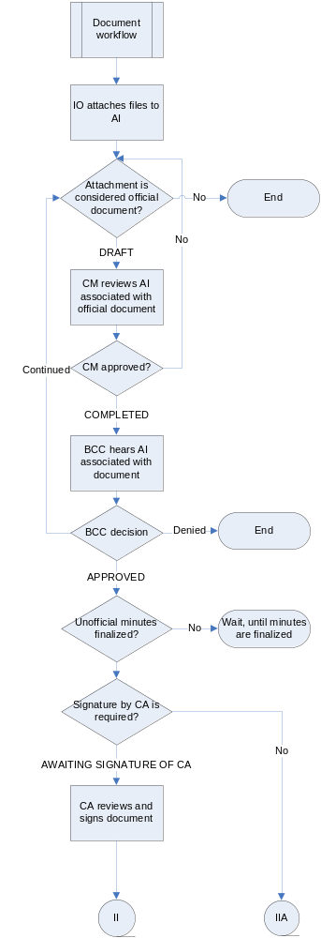

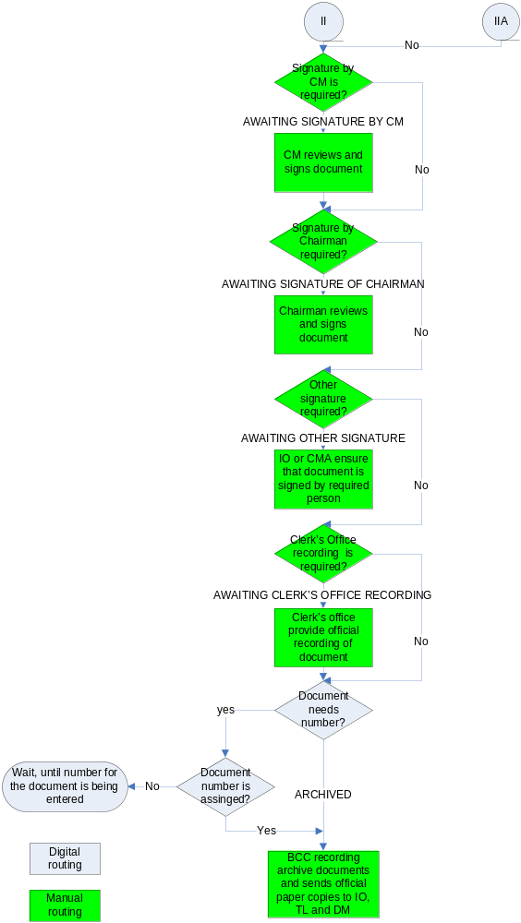

Once the document has been recorded and a copy gets sent to the IO, TL, and DM; the document action form will be handled exactly as it is.

BCC recording (Priority 1)

Description:
The BCC recording performs two main functions related to the post-BCC agenda workflow. It assigns document numbers to the official agenda documents, and it provides agenda system with the official minutes of the BCC meeting. Because the document number can be assigned at any stage, from approval of agenda item until the archiving of the documents, the BCC recording user does not participate in the workflow. This user assigns the documents number using the search engine and the main document page. The same search engine can be used to upload the official minutes for the past BCC meetings. The Agenda system does not participate in the generation of the official BCC minutes.

Business requirements:
      - The BCC Recording assigns file number, makes requested copies per Document Action Form and returns to Planning Staff Assistant. System handling resumes. Staff Assistant will indicate in the system that signatures were obtained and the item will be marked complete.
      - The BCC recording user needs a special search engine to perform the search of the BCC meetings and the official documents requiring action from the BCC recording.
a. Search criteria include:
- BCC date
- Type of document (i.e. ordinance, resolution, agreement, etc.)
b. Search results for the BCC recording should display the existence/absence of the official minutes for particular BCC date, and the list of official documents that require assignment of the document numbers.
c. The BCC recording user should be allowed to upload files with existing official minutes and finalize them once selection of proper file is done (These requirements are not part of agenda, user will upload file with text called “official BCC minutes”).
d. The BCC recording user should be able to assign numbers for the searched documents by selecting the appropriate document number.
e. The Agenda system should generate the document numbers’ list according to the known business rules. The Agenda system should be responsible for preventing multiple number assignments or missing numbers.
Resolutions should have the following numbers:
- Four digits of calendar year of date approved-R- consecutive number
Ordinances should have the following numbers:
- Four digits of calendar year of date approved-consecutive number
f. The BCC recording user will participate in the Notifications module: This user will receive notifications, when document requires number assignment. Notification will be sent when the user will archive the document and upload the official minutes. (Refer to the specifications for documents Notification portion for details)

Maintenance (Priority 2. Next Agenda Version)

System maintenance is the module of the agenda system that allows authorized users to maintain default settings of all the agenda modules including project, calendar, agenda item, report, notifications and post-BCC modules. The Maintenance module will allow users to delete old, edit existing or create new setting for each module of agenda. In such case, users of the agenda system will be able to customize the system every time whenever the business rules of the agenda process are changed. Access to the maintenance system should be limited to authorized users only.

Business requirements:
- The Maintenance module will include 5 main parts: maintenance of the process/project; maintenance of the calendar; maintenance of the page messages, maintenance of e-mail notifications, and other maintenance.
- Maintenance of the process will allow user to do the following:
  - Add, edit or delete project types assigned to a particular department/division
  - Add, edit or delete required attachments types for a particular project
  - Historical snapshot in time before edits will be kept. Deletion will not be allowed before archived.
  - A review process outside of the department/division prior to edit would be beneficial. Sometimes a group changes a process and is unaware of the negative effect on other groups. Perhaps some level of edits would benefit from review by higher group made up of the authorized users from an individual division/department.
- The user would have to select from the complete list of processes within each division/department, which one needs to be edited or deleted.
- Changes in the process types should be always related to the changes in the required attachments and standard wording in the memo page or related to changes in legal requirements via Land Development Code, Comp Plan, Fl Statutes, etc. Because changes in the process types, required attachments are very important. The confirmation screen should always precede any final changes in the process types/ required attachments.
- Maintenance of the calendar will allow user to do the following:
    - Add, edit or delete default BCC dates
    - Add edit or delete agenda types
    - Add, edit or delete session types
- Users would have to select from the list of existing default dates within each session type, which one needs to be edited or deleted.
- Changes in agenda types should be always related to the changes in the session types
- Changes in session types should be always related to the changes in default BCC dates. Because changes in the default date, the agenda types and the session types are very important. The confirmation screen should always precede any final changes in default dates, agenda types and session types.
- The maintenance of the page messages will allow users to do the following: add, delete message from a particular page, edit message text, buttons or conditions, and disable message for particular users.
- Users would have to select from the list of existing message within each page, which one needs to be edited or deleted. Because changes in the messages are very important, the confirmation screen should always precede any final changes in the page messages.
- The maintenance of e-mail notifications will allow users to do the following: add new or delete existing notification; edit notification title, text, notification condition or list of users, who will receive it; edit re-occurrence of notifications, and disable notification for particular users/groups of users.
- Users would have to select from the list of existing notifications which one needs to be edited or deleted. Because changes in the notifications are very important, the confirmation screen should always precede any final changes in notifications module.
- Other maintenance part will allow user to do the following: add, edit or delete District Commissioners names, edit name of the Chairman, add, edit or delete list of departments and divisions, and add, edit or delete standard wording in the agenda memo page.
- Changes in the list of departments and divisions should be always related to the changes in the process in the project module. Sometimes process stays the same, but divisions reorganize or change their names.
- Users would have to select from the list of existing District Commissioners’ names, which one needs to be edited or deleted.
- Users would have to select from the list of existing departments/ divisions, which one needs to be edited or deleted.
- Because changes in the district commissioners’ names, standard memo wording, and departments/divisions are very important, the confirmation screen should always precede any final changes.

Additional SCINET Team Added Known Requirements: (Priority 2. Next Agenda Version)

Replace the existing SCINET Inbox functionality with Seminole County’s E-Mail Package using the To Do functionality of the E-Mail Package (Priority 2. Next Agenda Version)

Agenda Item, agenda item document, and agenda report user notes / comments (Priority 2. Next Agenda Version)
Ability to review a BCC meeting agenda report and agenda items prior to the actual BCC meeting or at the actual BCC meeting to create a list of comments against any agenda report line item (agenda item, award & presentation item, miscellaneous item, etc.) or actual agenda item content or agenda item document content using their own PC including the tablet PC and have those comments available for review to them at any time online.

EXPECTATIONS

Expectations and Use Case Scenarios

- All agenda information should be located in one place.
Use Cases:
    - Users would be able to access all information about agenda item, agenda, agenda minutes and documents approved at BCC hearing in one database of agenda application.

- Tracking of agenda-related information should be accessible to all users.
Use cases:
    - Agenda application will allow both internal and external customers access the search engine to track information about agenda items review process.
    - All newly created AI, documents, agendas and minutes will have unique tracking number usable for tracking.

- All redundant agenda information should be eliminated from the local datasets of different divisions/departments.
Use cases:
    - Users such as “coordinator for planning”, “coordinator of development review”, “assistant for P&D department director” , “coordinator of CAO”, “assistant for DCM”, and “assistant for fiscal services director” would use one database to track movement of agenda items and documents associated with it.
    - Shared data base of agenda information would reflect changes in agenda-related information simultaneously for all users. No redundant or contradicting information would be saved independently for each user.

- The system will provide users a confirmation screen before they take important action towards agenda items/documents.
Use Cases:
    - The system will ask the users to validate their data (check for correct spelling of name; input all the required fields, etc.).
    - The customer receives a tracking number, confirmation that the application has been received and information concerning the next step in the process.

- All documents and attachments must be in digital format.
Use Cases:
    - This will eliminate physically transporting paper.
    - If the customer cannot provide supporting documentation in digital format, the paper form will be scanned when received by the County.

- Excel spreadsheets, access databases, word document tables, and other manual ways of tracking agenda items will be eliminated

- The system will maintain a complete record of all documentation and data related to each process. The relationships between various processes will also be maintained.
Use Case:
    - The IO searches for an agenda item. He will be able to view any data that is related to this item. He is able to look at the history by clicking on a button that shows all the relevant data. Information such as: confirmed date, mailed out date, printed out date, etc.

- The system will forward data completed during any prior process. There will be no duplicate data entries.
Use Case:
    - The system automatically supplies known information about agenda item (i.e. applicant name and address, project name, project address, BCC date, session time, contact information, etc).

- The system where applicable will provide auto-fill for important agenda-related fields
Use cases:
    - System will use standard wording for fields, if possible
    - When agenda application uses information from other systems, it wills auto-fill this information to eliminate entry errors and/or contradictions, if possible.

- The system will validate input into fields where applicable.
Use Cases:
    - The main fields cannot be blank.
    - Text cannot be entered into numerical fields.
    - Contact information must be there.

- The system will automatically send reminder of due dates and allow individuals to set reminders.
Use Cases:
    - The default reminders will be set by the system.
    - Reviewers will be able to set reminders for themselves. (i.e.: 300 feet notice must be sent by Tuesday).
    - Copies of individual reminders will be sent to their supervisor/manager escalating with the urgency.

- The system will provide customers the ability to give a feedback and comments.
Use Cases:
    - The IO notices a new field is missing from a standard report. She clicks on the feedback button and makes a request for change to the report.
    - The system adds comments to enable reporting on system quality.

- Every capability of the system must be available using a web browser.

- Agenda system will be able to provide information to the users in the real time, when applicable:
Use case:
    - IO and other agenda users will receive information about BCC decisions related to particular item at the time when assistant to DCM/CM will update unofficial minutes.
    - External users will be able to see approvals of agenda item reviews at the same time when such approvals will be completed by reviewers
    - Division staff will receive information about assigned numbers to resolutions and ordinances at the time when BCC recording will provide such numbers to the system

- Agenda system will allow generating reports by any query for any part of agenda process: agenda items, documents, agendas, and minutes:
Use case:
    - Search module enable search for agenda items, agenda document, 300-feet notices, placard, proofs of publication, unofficial and official minutes, and agendas. Results of search will be used as reports.
    - Coordinators for divisions and department will have tracking sheets, that can be used as report for agenda items and documents entering their offices for review

- Agenda system will be tied with divisions’ processes: development review, planning, building and community resources:
Use case:
    - Users will receive information and documents for agenda items from other processes.

- System should work with existing e-mail applications and be compatible with other Seminole County software
User case:
    - Notification module of agenda application will work through existing e-mail application used in Seminole County

- Agenda application would have access to digital maps prepared within Seminole County:
Use case:
    - Agenda system will have access to shared device with all cartographical information. This information would have identifiable names and would be attached to agenda item when necessary. All users of agenda system would have access to the same version of digital maps.
    - The live version of geography (map) is kept up to date by GIS using their normal processes. The actual map document attached to the agenda item is a static point in time map graphic and is never updated.

- This system will make people more accountable for meeting deadlines.
Use Cases:
    - Increased knowledge – all staff views the same info. The system will be up-to–date, accurate, and everyone will know exactly where they are in the process. Data can be located with any single piece of knowledge.
    - Accountability – The system will generate reports of deadlines met or not met and why not.

Appendix 1. Project, Processes and Conditions

# | Division | Process Group | Process types | Required proof of publication | Required 300’ notice | Required placard posting
1 | Planning | Administrative | Code enforcement lien reduction | No | No | No
2 | Planning | BOA | BOA Appeals of variances and special exceptions | Yes | Yes | Yes
3 | Planning | Current Planning | Straight Rezone without site plan | Yes | Yes | Yes
4 | Planning | Current Planning | Rezone with site plan to - PUD, PCD, OP, RP, RM-2, RM-3, R-3, R-3A, R-4 | Yes | Yes | Yes
5 | Planning | Current Planning | PUD/PCD Major Amendment | Yes | Yes | Yes
6 | Planning | Current Planning | PUD Final Master Plan | No | No | No
7 | Planning | Current Planning | PCD Final Site Plan | No | No | No
8 | Planning | Long Range Planning | Dev Regional Impact (DRI) | Yes | Yes | Yes
9 | Planning | Long Range Planning | Small Scale F L U A with no Rezone | Yes | Yes | Yes
10 | Planning | Long Range Planning | Large Scale F L U A - Transmittal hearing with no Rezone | Yes | Yes | Yes, if changes pertain to particular territory, no if changes influence county-wide territory
11 | Planning | Long Range Planning | Large Scale F L U A - Adoption hearing with no Rezone | Yes | Yes | Yes, if changes pertain to particular territory, no if changes influence county-wide territory
12 | Planning | Long Range Planning | Large Scale F L U Text Amendment | Yes | Yes, if changes pertain to particular territory, no if changes influence county-wide territory. | Yes, if changes pertain to particular territory, no if changes influence county-wide territory.  Image from proof of publication is used in 300’ letter.
13 | Planning | Long Range Planning | LDC Amendment | Yes | Yes, if changes pertain to particular territory, no if changes influence county-wide territory. | Yes, if changes pertain to particular territory, no if changes influence county-wide territory.
14 | Planning | Both Current and Long Range Planning | Board briefing | No | No | No
15 | Planning | Both Current and Long Range Planning | Small Scale F L U A and Straight Rezone | Yes | Yes | Yes
16 | Planning | Both Current and Long Range Planning | Small Scale F L U A with site plan Rezone | Yes | Yes | Yes
17 | Planning | Both Current and Long Range Planning | Large Scale F L U A Transmittal hearing with Straight Rezone | Yes | Yes | Yes
18 | Planning | Both Current and Long Range Planning | Large Scale F L U A Adoption hearing with Straight Rezone | Yes | Yes | Yes
19 | Planning | Both Current and Long Range Planning | Large Scale F L U A Transmittal hearing with site plan Rezone | Yes | Yes | Yes
20 | Planning | Both Current and Long Range Planning | Large Scale F L U A Adoption hearing with site plan Rezone | Yes | Yes | Yes
21 | Development Review | Development Review Planning | Site plan modification | No | No | No
22 | Development Review | Development Review Planning | Final plat approval | No | No | No
23 | Development Review | Development Review Planning | Minor plat approval | No | No | No
24 | Development Review | Development Review Planning | Drainage easement vacate | Yes | Yes | Yes
25 | Development Review | Development Review Planning | Utility easement vacate | No | No | No
26 | Development Review | Development Review Planning | Drainage and utility easement vacate | Yes | Yes | Yes
27 | Development Review | Development Review Planning | Right – of way vacate | Yes | Yes | Yes
28 | Development Review | Development Review Planning | Conservation drainage easement vacate | Yes | Yes | Yes
29 | Development Review | Development Review Planning | Plat vacate | Yes | Yes | Yes
30 | Development Review | Development Review Planning | Release of performance bond | No | No | No
31 | Development Review | Development Review Planning | Preliminary subdivision approval | No | No | No
32 | Development Review | Development Review Engineering | Borrow pit extension | Yes | Yes | Yes
33 | Development Review | Development Review Engineering | Borrow pit new | Yes | Yes | Yes
34 | Development Review | Development Review Engineering | Dock permit | Yes, if square feet of dock is more than 1000 feet, no, if less | Yes, if square feet of dock is more than 1000 feet, no, if less | Yes, if square feet of dock is more than 1000 feet, no, if less
35 | Community Resources | Imaging, CSI, and Natural Land | Board briefing | No | No | No
36 | Community Resources | Imaging, CSI, and Natural Land | Agreement | No | No | No
37 | Community Resources | Imaging, CSI, and Natural Land | Miscellaneous, imaging | No | No | No
38 | Community Resources | Imaging, CSI, and Natural Land | Miscellaneous,  SCI | No | No | No
39 | Community Resources | Imaging, CSI, and Natural Land | Miscellaneous,  Natural lands | No | No | No
40 | Community Resources | Addressing | Street name change | No | No | No
41 | Community Resources | Addressing | Miscellaneous, addressing | No | No | No
42 | Building |  | Amendments to Building Code | Yes | No | No
43 | Building |  | Appeal of Building board decision | No | No | No
44 | Building |  | Appeal of mechanic board decision | No | No | No
45 | Building |  | Appeal of swimming pool board decision | No | No | No
46 | Building |  | Appeal of plumbing board decision | No | No | No
47 | Building |  | Appeal of electrical board decision | No | No | No
48 | Building |  | Appeal of drilling board decision | No | No | No
49 | Building |  | Flood Mitigation Assistance agreement | No | No | No
50 | Building |  | Miscellaneous, building | No | No | No

Appendix 2. Agenda Process, Attachments and Official Documents
(Attachments marked by * are considered as official documents, attachment marked as ** are considered as maps)

# | Division | Process types | Unconditionally Required attachments | Conditionally required attachments
1 | Planning | Code enforcement lien reduction | - Findings of fact, conclusion of law and order  - Affidavit of non-compliance  - Order finding non-compliance and imposing fine  - Affidavit of compliance  - Request for reduction of penalty  - Property appraisal database information  - Estimated cost of processing case by Planning  - Estimated cost for processing case by CEB by SCSO | - Amended findings of fact (if any)
2 | Planning | Board briefing | None | None
3 | Planning | Straight Rezone without site plan | 1. Zoning map**  2. Aerial map**  3. Location map**  4. Ordinance*  5. P&Z minutes | 1. Prior BCC minutes (if any exist)
4 | Planning | Rezone with site plan to - PUD, PCD, OP, RP, RM-2, RM-3, R-3, R-3A, R-4 | 1. Zoning map**  2. Aerial map**  3. Location map**  4. Site plan (11 X17)**  5. Ordinance*  6. Development order*  7. P&Z minutes | 1. Prior BCC minutes (if any exist)
5 | Planning | PUD/PCD Major Amendment | 1. Zoning map**  2. Aerial map**  3. Location map**  4. Site plan (11 X17)**  5. Ordinance*  6. Development order*  7. P&Z minutes | 1. Prior BCC minutes (if any exist)  2. Development commitment agreement
6 | Planning | PUD Final Master Plan | 1.Location map**  2.Site plan (11 X17)**  3.Development commitment agreement* | None
7 | Planning | PCD Final Site Plan | 1.Location map**  2.Site plan (11 X17)**  3.Development commitment agreement*  4.P&Z minutes | 1. Prior BCC minutes (if any exist)
8 | Planning | Dev Regional Impact (DRI) | 1.Zoning map**  2. Aerial map**  3. Location map**  4. Site plan (11 X17)**  5. Ordinance*  6. Development order*  7. P&Z minutes | 1. Prior BCC minutes (if any exist)
9 | Planning | BOA Appeals of variances and special exceptions | 1. Zoning map**  2. Aerial map**  3. Location map**  4. P&Z minutes | 1.Prior BCC minutes (if any exist)
10 | Planning | Small Scale F L U A with no Rezone | 1. Zoning map**  2. Aerial map**  3. Location map**  4. Ordinance*  5. P&Z minutes | 1. Prior BCC minutes (if any exist)
11 | Planning | Small Scale F L U A and Straight Rezone | 1. Zoning map**  2. Aerial map**  3. Location map**  4. Ordinance*  5. P&Z minutes | 1. Prior BCC minutes (if any exist)
12 | Planning | Small Scale F L U A with site plan Rezone | 1. Zoning map**  2. Aerial map**  3. Location map**  4. Site plan (11 X17)**  5. Ordinance*  6. Development order*  7. P&Z minutes | 1. Prior BCC minutes (if any exist)
13 | Planning | Large Scale F L U A - Transmittal hearing with no Rezone | 1. Zoning map**  2. Aerial map**  3. Location map**  4. Ordinance*  5. P&Z minutes | 1. Prior BCC minutes (if any exist)
14 | Planning | Large Scale F L U A - Adoption hearing with no Rezone | 1. Zoning map**  2. Aerial map**  3. Location map**  4. Ordinance*  5. Development order*  6. P&Z minutes | 1. Prior BCC minutes (if any exist)
15 | Planning | Large Scale F L U A Transmittal hearing with Straight Rezone | 1. Zoning map**  2. Aerial map**  3. Location map**  4. Ordinance*  5. P&Z minutes | 1. Prior BCC minutes (if any exist)
16 | Planning | Large Scale F L U A Adoption hearing with Straight Rezone | 1. Zoning map**  2. Aerial map**  3. Location map**  4. Ordinance*  5. P&Z minutes | 1. Prior BCC minutes (if any exist)
17 | Planning | Large Scale F L U A Transmittal hearing with site plan Rezone | 1. Zoning map**  2. Aerial map**  3. Location map**  4. Ordinance*  5. P&Z minutes | 1. Prior BCC minutes (if any exist)
18 | Planning | Large Scale F L U A Adoption hearing with site plan Rezone | 1. Zoning map**  2. Aerial map**  3. Location map**  4. Site plan (11 X17)**  5. Ordinance*  6. P&Z minutes | 1. Prior BCC minutes (if any exist)
19 | Planning | Large Scale F L U Text Amendment | 1. P&Z minutes | 1. Prior BCC minutes (if any exist)
20 |  | LDC Amendment | 1. P&Z minutes | 1. Prior BCC minutes (if any exist)
21 | Development review | Site plan modification | - Resolution*  - Location map/aerial**  - Previously approved site plan  - New site plan | 1. Copy of recorded plat (in necessary)  2. Sketch of description ( if necessary)
22 | Development review | Final plat approval | - Location map**  - Copy of recorded plat | None
23 | Development review | Minor plat approval | - Location map**  - Copy of recorded plat | None
24 | Development review | Drainage easement vacate | - Location map**  - Sketch of description  - Resolution* | None
25 | Development review | Utility easement vacate | - Location map**  - Sketch of description  - Resolution* | None
26 | Development review | Drainage and utility easement vacate | - Location map**  - Sketch of description  - Resolution* | None
27 | Development review | Right – of way vacate | - Location map**  - Sketch of description  - Resolution* | None
28 | Development review | Conservation drainage easement vacate | - Location map**  - Sketch of description  - Resolution* | None
29 | Development review | Plat vacate | - Location map**  - Resolution*  - Plat reduction  - Aerial map** | None
30 | Development review | Release of performance bond | 1. Performance Bond | None
31 | Development review | Preliminary subdivision approval | - Location map**  - Reduced copy of PSP (preliminary subdivision plan) | None
32 | Development review | Borrow pit extension | 1. Location map** | None
33 | Development review | Borrow pit new | - Location map**  - Reduced copy of plan | None
34 | Development review | Dock permit | - Location map**  - Dock plan | None
35 | Community resources (includes imaging, CSI and natural land) | Board briefing | None | None
36 | Community resources (includes imaging, CSI and natural land) | Agreement | - Agreement*  - Location map** | Public comment (if any)
37 | Community resources (includes imaging, CSI and natural land) | Miscellaneous, imaging | None | None
38 | Community resources (includes imaging, CSI and natural land) | Miscellaneous,  SCI | None | None
39 | Community resources (includes imaging, CSI and natural land) | Miscellaneous,  Natural lands | None | None
40 | Community resources/addressing | Street name change | - Resolution*  - Map** | -Copy of Public Safety department request ( if any)  - Copy of notify letter (for residents of the street)  - Copy of outcome letter  - Public comments (if any)
41 | Community resources/addressing | Miscellaneous | None | None
42 | Building | Amendments to Building Code | 1. Ordinance * | None
43 | Building | Appeal of Building board decision | - Findings and order of building board  - Notice of appeal to BCC  - Minutes of building board hearing | None
44 | Building | Appeal of mechanic board decision | - Findings and order of mechanic board  - Notice of appeal to BCC  - Minutes of mechanic board hearing | None
45 | Building | Appeal of swimming pool board decision | - Findings and order of swimming pool  - Notice of appeal to BCC  - Minutes of swimming pool board hearing | None
46 | Building | Appeal of plumbing board decision | - Findings and order of plumbing board  - Notice of appeal to BCC  - Minutes of plumbing board hearing | None
47 | Building | Appeal of electrical board decision | - Findings and order of electric board  - Notice of appeal to BCC  - Minutes of electric board hearing | None
48 | Building | Appeal of drilling board decision | - Findings and order of drilling board  - Notice of appeal to BCC  - Minutes of building drilling hearing | None
49 | Building | Flood Mitigation Assistance agreement | 1. Flood Mitigation assistance agreement* | None
50 | Building | Miscellaneous, building | None | None

Appendix 3. Main Workflow Statuses Table

Status | Description | Button that triggers change of status | FROM  (users initiating change of this status) | TO  (user receiving this AI in the inbox)
Pending | User creates agenda item and saves it to his/her inbox | Save | None | IO
Schedule requested | User requests approval of BCC date, session time and agenda type from assistant of DCM/CM | Schedule | IO | DCM/CM assistant
Scheduled | User notifies about approval of BCC date, session time and agenda type | Approve schedule | DCM/CM assistant | IO
Schedule denied | User notifies about disapproval of BCC date, session time and agenda type | Reject schedule | DCM/CM assistant | IO
Reschedule requested | User requests change of BCC date, session time or/and agenda type from assistant of DCM/CM | Reschedule | IO | DCM/CM assistant
Rescheduled | User notifies about approval of date/time/type change | Approve schedule | DCM/CM assistant | IO
Review of team leader 1 | Item is being reviewed first time by team leader within division | Send to reviewer | IO | TL
Returned by team leader 1 | Item is being returned to item originator by team leader first time | Return to IO | TL | IO
Review of assistant division manager 1 (only for planning) | Item is being reviewed first time by the Assistant Division Manager within the division where the item belongs to | Send to reviewer | TL | ADM
Returned by Assistant Division Manager 1 | Item is being returned to item originator by the Assistant Division Manager first time | Return to IO | ADM | IO
Review of Division Manager 1 | Item is being reviewed first time by the Division Manager within the division where the item belongs to | - Send to reviewer  (for Building and some projects of Community Resources)  - Approve (the rest of divisions/projects) | - IO (for Building and some projects of Community Resources)  - TL (for Development Review and some projects of Community Resources)  - ADM (for planning) | DM
Returned by Division Manager 1 | Item is being returned to Item Originator by the Division Manager first time | Return to IO | DM | IO
Review of Assistant for Director 1 | Item is being reviewed first time by Assistant of Director Department | Approve | DM | Assistant for Director
Returned by Assistant for Director 1 | Item is being returned to Item Originator by Assistant for Director first time | Return to IO | Assistant for Director | IO
Review by the Director 1 | Item is being reviewed first time by the Director of the Department | Approve | Assistant for Director | director
Returned by the Director 1 | Item is being returned to Item Originator by the Director for the first time | Return to IO | P&D Department Director | IO
Review by the Revenue Analyst 1 | Item is being reviewed by the Revenue Analyst for the first time | Approve | P&D Department Director | Revenue Analyst
Returned by the Revenue Analyst 1 | Item is being returned to Item Originator by the Revenue Analyst for the first time | Return to IO | Revenue Analyst | IO
Review by the Grant Analyst 1 | Item is being reviewed by the Grant Analyst for the first time | Approve | P&D Department Director | Grant analyst
Returned by the Grant Analyst 1 | Item is being returned to Item Originator by the Grant Analyst for the first time | Return to IO | Grant Analyst | IO
Review by the Budget Manager 1 | Item is being reviewed by the Budget Manager for the first time | Approve | P&D Department Director | Budget Manager
Returned by the Budget Manager 1 | Item is being returned to Item Originator by the Budget Manager for the first time | Return to IO | Budget Manager | IO
Review by the Fiscal Services Director 1 | Item is being reviewed by the Director of Fiscal Services for the first time | Approve | Budget Manager/ Revenue Analyst /Grant Analyst | Fiscal Services Department Director
Returned by the Fiscal Services Director 1 | Item is being returned  to Item Originator by the Fiscal Services Director for the first time | Return to IO | Fiscal Services Department Director | IO
Review by the CAO Coordinator 1 | Item is being reviewed by the CAO Coordinator for assigning Attorney | Approve | - Director of P&D Department (if none FS review is necessary)  - Director of the Fiscal Services Department | CAO Coordinator
Returned by the CAO Coordinator | Item is being returned by the CAO Coordinator to IO | Return to OI | CAO | IO
Review by the Attorney 1 | Item is being reviewed by the Attorney for the first time | Assign | CAO Coordinator | Attorney
Returned by the Attorney 1 | Item is being returned by the Attorney for the first time | Return to IO | Attorney | IO
Review by the Assistant for DCM/CM 1 | Item is being reviewed by the Assistant DCM/CM | Approve | Attorney | DCM/CM assistant
Returned by assistant for DCM/CM 1 | Item is being returned by assistant for DCM/CM first time | Return to IO | DCM/CM assistant | IO
Review by DCM 1 | Item is being reviewed by DCM for the first time | Approve | DCM/CM assistant | DCM
Returned by DCM 1 | Item is being returned by DCM for the first time | Return to IO | DCM | IO
Review by CM1 | Item is being reviewed by CM for the first time | Approve | DCM | CM
Returned by CM1 | Item is being returned by CM to IO for the first time | Return to IO | CM | IO
Completed | Item is being approved by all reviewers | Approve | CM | None
Returned by CM | Item is being returned by CM for the first time | Return to IO | CM | IO
Withdrawn | Item is being permanently removed from the workflow | Withdraw | IO | None
On hold | Item is being temporary removed from the workflow | On hold | IO | None
Scheduled, continued | Item is being continued with particular date by BCC authorities. Agenda Item was sent to IO for update | Selection of “Continued” option from decision menu of unofficial BCC minutes and selection of date from “Future BCC date” drop-down list. | Assistant for DCM/CM | IO
Pending, continued | Item is being continued with no particular date by BCC. Agenda Item was sent to IO for new scheduling | Selection of “Continued” option from decision menu of unofficial minutes and selection of “no date” option from “future BCC date” drop-down list. | Assistant for DCM/CM | IO
Approved | Item is being approved by BCC | Selection of “approved” option from decision menu of unofficial minutes | Assistant for DCM/CM | - None  - Coordinator of CAO (if any official documents are attached)
Denied | Item is being denied by BCC | Selection of “denied” option from decision menu of unofficial minutes | Assistant for DCM/CM | None

Appendix 4. Document Action Form Template

Initial and date
County Managers Office: AGENDA ITEM NUMBER:
Chairman’s Office:
Recording:

DOCUMENT ACTION FORM

DATE:
SUBJECT:

AUTHORITY FOR PROCESSING: Signature

- Date for item to be placed on BCC Agenda Meeting:

- Signature Needed by Chairman: Yes No

- Date BCC approved item:

- Other [Specify]:

NOTE: One original and one copy of document or letter needed for original signature (Not applicable for Resolutions or Ordinances - original only.)

Additional copies of documents should be forwarded if applicable and required for proper distribution.

DIRECTIONS FROM ORIGINATING DEPARTMENT FOR FINAL PROCESSING OF ORIGINAL. EXECUTED DOCUMENTS BY COUNTY COMMISSION RECORDS -

Directions for County Managers Office:

Directions for Commission Records:

Staff Contact: Extension:

Please return this form to originator: Yes No

Appendix 5. Unofficial BCC Minutes Template

SEMINOLE COUNTY
BOARD OF COUNTY COMMISSIONERS
UNOFFICIAL MINUTES
TUESDAY, SEPTEMBER 26, 2006

The Seminole County Board of County Commissioners Agenda meeting is now archived to video and available for viewing. You can view the meeting two ways: you can view the morning, afternoon, and evening sessions by viewing the files listed below; or, you can view search agenda item listed below with a link.

Both viewing options have been recorded in windows media video format and you will need a video player that supports that format.

morning afternoon night

In order to view the video by agenda items, you will need Windows Media Player version 7.1 or above.

video player downloads:
realplayer
windows media player

view video
Chairman Convened BCC Meeting at 9:30 A.M.

Opening Ceremonies

- Invocation
- Pledge of Allegiance

Awards and Presentations:

1. view video

Resolution –(Brief description)– Board (decision). (#-#)

2. view video

Resolution –(Brief description)– Board (decision). (#-#)

3. view video

Presentation–(Brief description) Board (decision). (#-#)

Consent Agenda
(EXAMPLE
County Manager’s Consent Agenda Items No. 8 – 37 – Board unanimously approved Items 8-37 with Item No. 12 being moved to the November 7th BCC meeting and Item No. 22 pulled for separate discussion. (5 – 0). After discussion the Board ranked the firm of American Bridge as the number one firm with recommendations for the U.S. 17-92 Pedestrian Overpass Design Build Project, and Southland Construction Company of Apopka as the number two ranked firm. (5 – 0))

view video

Constitutional Officers Consent Agenda Items No. #- #
(EXAMPLE
Clerk’s Office (Maryanne Morse, Clerk of the Court) – Board unanimously approved Items 38-41. (5 – 0))

- Regular Agenda

- County Manager’s Briefing

- County Attorney’s Briefing

- Chairman Recessed BCC Meeting until 1:30 P.M.

view video
- Chairman Reconvened BCC Meeting at 1:30 P.M.

- Public Hearing Agenda

- Accept Proofs of Publication

- Chairman’s statement of Public Hearing Rules and Procedures – Board (decision) Proofs of Publications. (# – #)

Public Hearings:

Chairman’s Report

view video
District Commissioner’s Report – District 2, 3, 4, 5 and 1

Commissioner (Name of 1)

Commissioner (Name of 2)

Commissioner (Name of 3)

Commissioner (Name of 4)

Commissioner (Name of 5)

Committee Reports

view video
County Manager’s Report

- Chairman Recessed BCC Meeting until 7:00 P.M.

view video
- Chairman Reconvened BCC Meeting at 7:00 P.M.

- Public Hearing Agenda

- Accept Proofs of Publication

- Chairman’s statement of Public Hearing Rules and Procedures – Board (decision) Proofs of Publications. (# – #)

Public Hearings:

Items for future Agenda – Commission, Staff, or Citizens

Adjourn BCC Meeting

PERSONS WITH DISABILITIES NEEDING ASSISTANCE TO PARTICIPATE IN ANY OF THESE PROCEEDINGS SHOULD CONTACT THE HUMAN RESOURCES DEPARTMENT, ADA COORDINATOR 48 HOURS IN ADVANCE OF THE MEETING AT 407-665-7941.

FOR ADDITIONAL INFORMATION REGARDING THIS NOTICE, PLEASE CONTACT THE COUNTY MANAGER’S OFFICE, AT 407-665-7219. PERSONS ARE ADVISED THAT, IF THEY DECIDE TO APPEAL DECISIONS MADE AT THESE MEETINGS / HEARINGS, THEY WILL NEED A RECORD OF THE PROCEEDINGS AND FOR SUCH PURPOSE, THEY MAY NEED TO INSURE THAT A VERBATIM RECORD OF THE PROCEEDINGS IS MADE, WHICH INCLUDES THE TESTIMONY AND EVIDENCE UPON WHICH THE APPEAL IS TO BE BASED, PER SECTION 286.0105, FLORIDA STATUTES.

